Step 1: To access survey metadata, users should download FileZilla, a free file transfer platform available at http://filezilla-project.org/ . Follow the provider’s instructions on how to download this application.
Step 2: Once you have FileZilla installed, open the application.
- On the menu bar, under the File tab, select “Site Manager”. This window should appear:
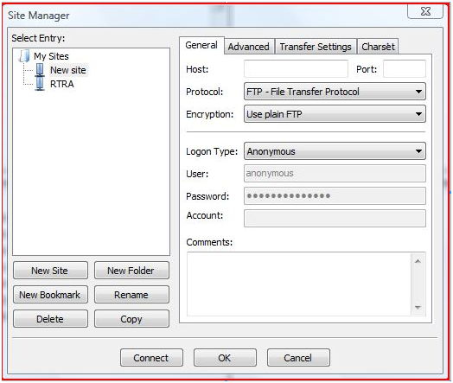
- On the site manager pane, click new site. Under the “select entry:” window, you can rename your new site to “RTRA”.
- On the site manager pane, under the General tab input the following into the fields specified:
  - Host: eftftp-ptftef.statcan.gc.ca
  - Protocol: FTP-File Transfer Protocol
  - Encryption Use plain FTP
  - Logon Type: Normal
  - User: Enter your EFT username here
  - Password: Enter your EFT password here
Once this is complete, your page should look like this:
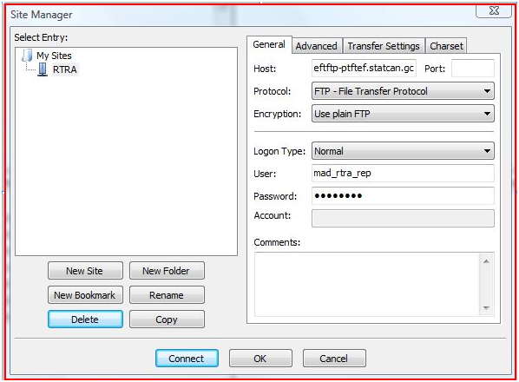

- On the site manager pane, under the Advanced tab, ensure that the “Bypass proxy” box is unchecked. Once this is complete, the advance tab should look like this:
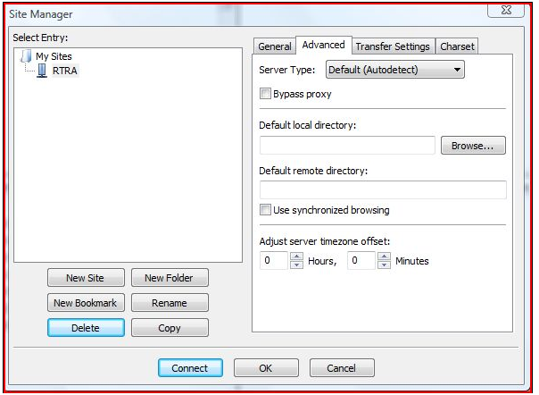

- On the Site Manager pane, under the Transfer Settings tab, ensure that the “Active” box under transfer mode is selected. Once this is complete, the Transfer Setting tab should look like this:
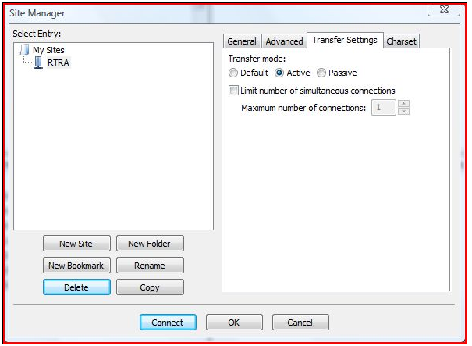

- You are now ready to connect. Click the Connect button on the Site Manager pane.
Step 3: Once you have connected, your FTP account should appear. You may now navigate the RTRA resources and metadata under the Remote Site pane, located to your right.
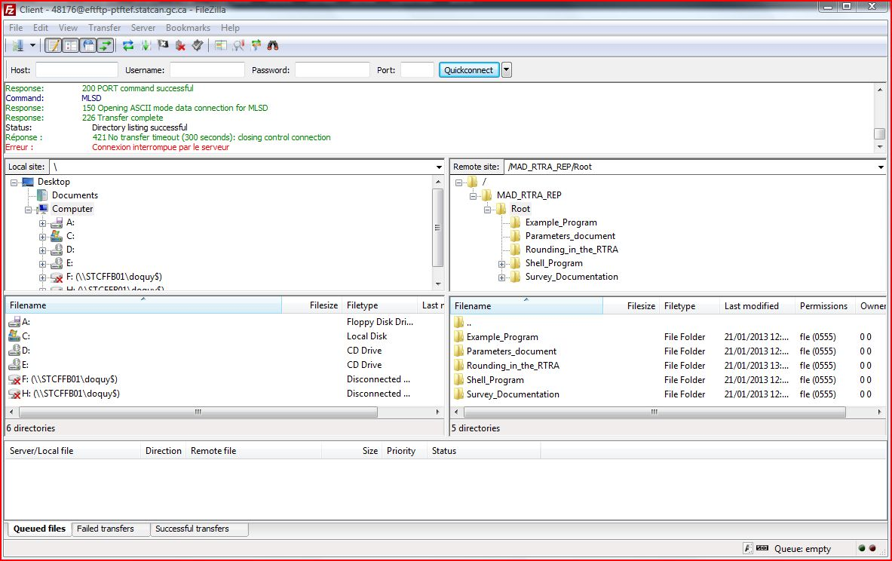

If you have any questions or difficulty in setting up your FTP account, please contact an RTRA agent at: rtra_adtr@statcan.gc.ca.

