Data Set: 2012 UCR victims

Research Question: Determine the number of and percentage of violent crimes against the person who is in a family relationship (partner or other) with the accused

SAS CODE | RTRA CODE
libname UCR_Vic "C:\RTRA\Surveys\UCR\Dummy_data";  data work.UCR;  set UCR_Vic.orig_vic2012_dummydata (keep= agg_relation vicsex viol relation);  /*Defining Sample*/  /*Assigning Family Relationship*/  If agg_relation= 01;  /*Assigning Gender*/  If vicsex= "M" then SexOfVictim= "MALE";  Else If vicsex= "F" then SexOfVictim= "FEMALE";  Else If vicsex= "O" then SexOfVictim= "OTHER";  /*Grouping by type of violation*/  If viol<= 1399 then Crime= "A-Homicide+Capital+SexualViol";  Else If 1400<= viol<= 1499 then Crime= "B-OtherAssaults";  Else If 1500<= viol<= 1599 then Crime= "C-DeprivationFreedom";  Else If 1600<= viol<= 1699 then Crime= "D-OtherCrimesAgainstPerson";  Else If 2000<= viol<= 9999 then Crime= "E-Other";  /*Grouping family relationships into two groups*/  If relation <= 02 then Partner="A-Partner";  Else if relation > 02 or relation= 00 then Partner="B-other";  proc freq data=UCR;  TABLES Parter*SexOfVictim*Crime;  run; | data work.UCR;  set RTRAdata.vic2012 (keep= vicsex viol agg_relation relation id);  /*Defining Sample*/  /*Assigning "Family" Relationship*/  If agg_relation=01;  /*Assigning Gender*/  If vicsex="M" then SexOfVictim="MALE";  Else If vicsex="F" then SexOfVictim ="FEMALE";  Else If vicsex="O" then SexOfVictim ="OTHER";  /*Grouping by type of violation*/  If viol<= 1399 then Crime= "A-Homicide+Capital+SexualViol";  Else If 1400<= viol<= 1499 then Crime= "B-OtherAssaults";  Else If 1500<= viol<= 1599 then Crime= "C-DeprivationFreedom";  Else If 1600<= viol<= 1699 then Crime= "D-OtherCrimesAgainstPerson";  Else If 2000<= viol<= 9999 then Crime= "E-Other";  /*Grouping family relationships into two groups*/  If relation <= 02 then Partner="A-Partner";  Else if relation > 02 or relation= 00 then Partner="B-other";  %RTRAFreq (  InputDataset=work.UCR,  OutputName=VictimsSex,  ClassVarList= Crime SexOfVictim Partner,  UserWeight=weight);  run;  NOTE: Save this code as: tagname_anythingyouwant.sas  Example: Save As UCR_test

SAS test results: Victim dummy data file (UCR 2012) | RTRA results: RTRA Victim master file (UCR 2012)
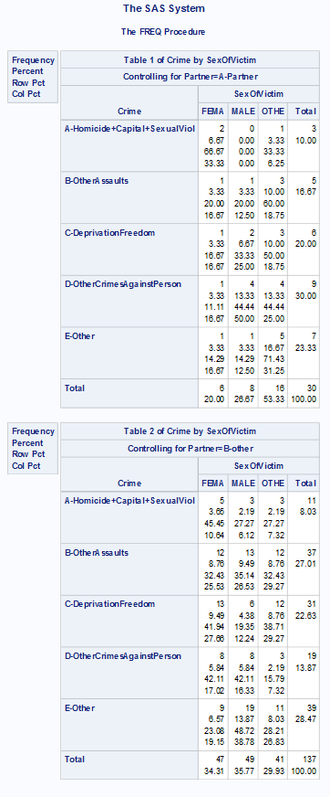 | SexOfVictim  FEMA MALE OTHE TOTAL FEMA MALE OTHE Total  Partner  Partner Partner Partner Partner B-other B-other B-other B-other  Crime  A-Homicide+Capital+SexualViol 963 15 0 978 5280 1299 15 6594  B-OtherAssaults 26565 7641 36 34242 17430 15120 66 32616  C-DeprivationFreedom 939 27 0 966 258 204 0 462  D-OtherCrimesAgainstPerson 7143 1251 6 8400 4800 4038 15 8853  E-Other 27 6 0 33 36 60 0 96  Total 35637 8940 42 44619 27804 20721 96 48621

