Data Set: UCR VIC2012

Research Question: Determine the number of and percentage of violent crimes against persons who are in a family relationship with the accused

SAS CODE | RTRA CODE
libname UCR_Vic "C:\RTRA\Surveys\UCR\Dummy_data";  data work.UCR;  set UCR_Vic.orig_vic2012_dummydata (keep= agg_relation vicsex viol);  /*Defining Sample*/  /*Assigning Family Relationship*/  If agg_relation= 01;  /*Assigning Gender*/  If vicsex= "M" then SexOfVictim= "MALE";  Else If vicsex= "F" then SexOfVictim= "FEMALE";  Else If vicsex= "O" then SexOfVictim= "OTHER";  /*Grouping by type of violation*/  If viol<= 1399 then Crime= "A-Homicide+Capital+SexualViol";  Else If 1400<= viol<= 1499 then Crime= "B-OtherAssaults";  Else If 1500<= viol<= 1599 then Crime= "C-DeprivationFreedom";  Else If 1600<= viol<= 1699 then Crime= "D-OtherCrimesAgainstPerson";  Else If 2000<= viol<= 9999 then Crime= "E-Other";  proc freq data=UCR;  TABLES Crime*SexOfVictim;  run; | data work.UCR_vic;  set RTRAdata.vic2012 (keep= vicsex viol agg_relation id);  /*Defining Sample*/  /*Assigning "Family" Relationship*/  If agg_relation=01;  /*Assigning Gender*/  If vicsex="M" then SexOfVictim="MALE";  Else If vicsex="F" then SexOfVictim ="FEMALE";  Else If vicsex="O" then SexOfVictim ="OTHER";  /*Grouping by type of violation*/  If viol<= 1399 then Crime= "A-Homicide+Capital+SexualViol";  Else If 1400<= viol<= 1499 then Crime= "B-OtherAssaults";  Else If 1500<= viol<= 1599 then Crime= "C-DeprivationFreedom";  Else If 1600<= viol<= 1699 then Crime= "D-OtherCrimesAgainstPerson";  Else If 2000<= viol<= 9999 then Crime= "E-Other";  %RTRAFreq (  InputDataset=work.UCR_vic,  OutputName=Table_DLI_19,  ClassVarList= Crime SexOfVictim,  UserWeight=weight);  run;  NOTE: Save this code as: tagname_anythingyouwant.sas  Example: Save As UCR_test

SAS test results: Victim dummy data file (UCR 2012) | RTRA results: RTRA Victim master file (UCR 2012)
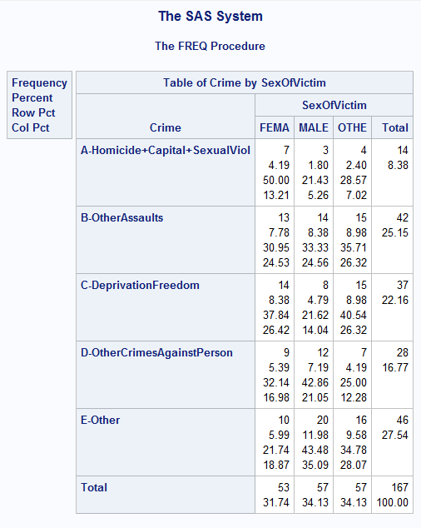 | 