DLI Ontario Regional Training December 2019RTRA Workshop: UCR Research question exercise

## Research Question:

Determine the number of and percentage of violent crimes against the person in intimate relationships with the victim

Specially, we intent to create the table below, but where do you start?

|  |  |  |  |  |
| --- | --- | --- | --- | --- |
| Type | Sex of Victim | | | |
| Female | Male | Other | Total |
| Assaults |  |  |  |  |
| Deprivation of Freedom |  |  |  |  |
| Homicide, Capital and Sexual Violence |  |  |  |  |
| Other |  |  |  |  |
| Other Crimes Against Person |  |  |  |  |
| Total |  |  |  |  |

## Step 1: Consult UCR Documentation

What variables would address your research question?

Variables of interest include:

* Family relationship
* Gender
* Violations against the person and property, drugs and other criminal violations

## Step 2: Write a SAS program

* Read in dummy data
* Keep variables of interest
* Record variables to make categories suitable for table above.
* Use a “Proc freq” command in SASS to specify your frequency table
* Run your program to test your code on the dummy data

## Step 3: Change your SAS program to make it compatible with RTRA

RTRA program requirements:

* Users need to reference a standard libname called RTRAData.
* To ensure access to the correct survey library, the tag name must be referenced in the title of your SAS program.
* The list of corresponding dataset names can be found in the RTRA parameters.

RTRA Parameters – Uniform Crime Reporting Survey

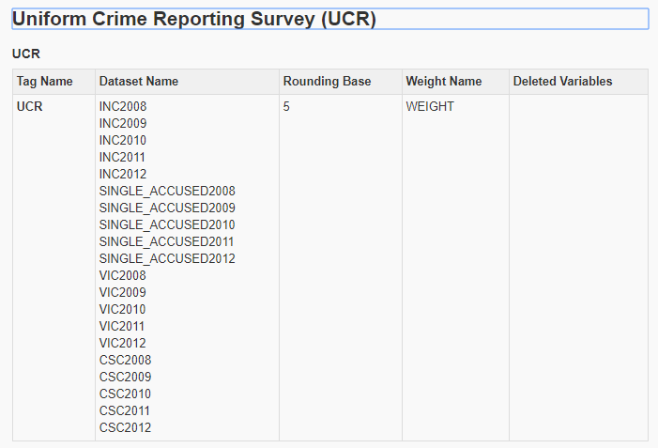

* When using the "keep" statement or "keep=" dataset option in SAS, you must include the 'ID' variable.
* Change your “proc freq” statement to a RTRA procedures macro

**data** work.UCR_Viol;

set RTRAdata.vic2012 (keep= agg-relation vicsex viol id);

***

%RTRAFreq(

InputDataset=,

OutputName=,

ClassVarList=,

UserWeight=);

## Step 4: Submit your RTRA program to the EFT

Follow the link to access the [Electronic File Transfer Service](https://www75.statcan.gc.ca/eft-tef) welcome page.