- FIND your Dream data !

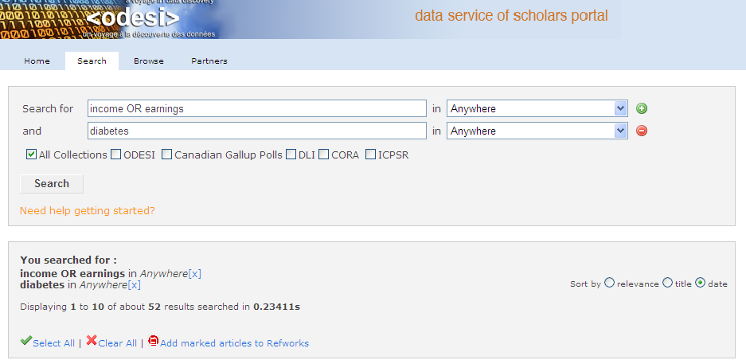
QUESTION:
DOES having more MONEY MEAN BETTER Health?
e.g., diabetes as a (negative) measure of health

2. look under the hood
Canadian Community Health Survey, 2005 : Cycle 3.1, Main File
WHAT DO THE DATA MEASURE?

Personal income from all sources

as measure of “money”

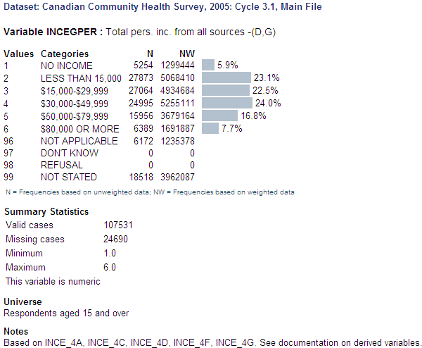
From where do the data come?  Answers from respondants:  Yes or no | 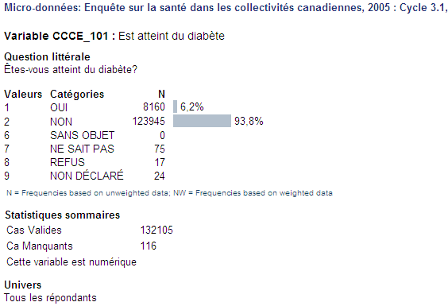

3. TABLES to go!

Click here

easy ! to add rows and columns to a table
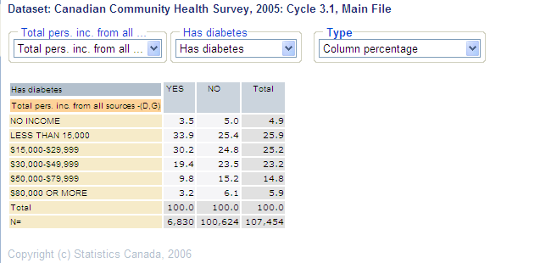  DOWNload statistics to a spreadsheet  The lower the income, the higher the percentage of diabetes  Weight your statistics so that they  represent the population of the survey  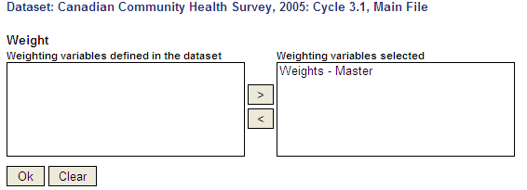  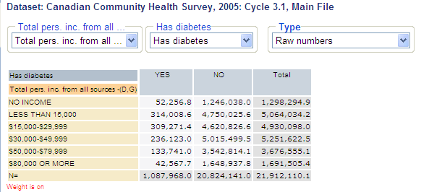 |  |  |  | 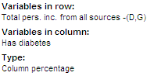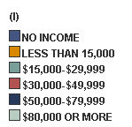  Print  to cut and paste !  or print-out  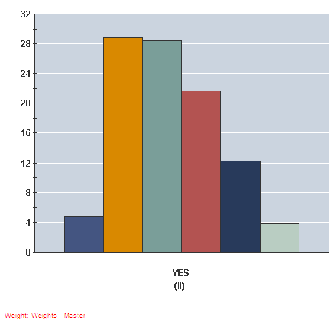
4. Pick and choose what you need!

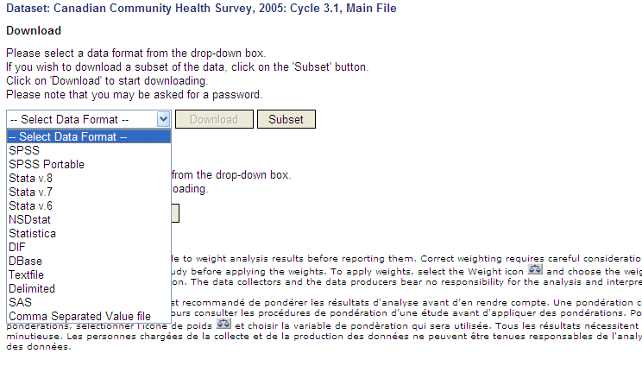
Download data

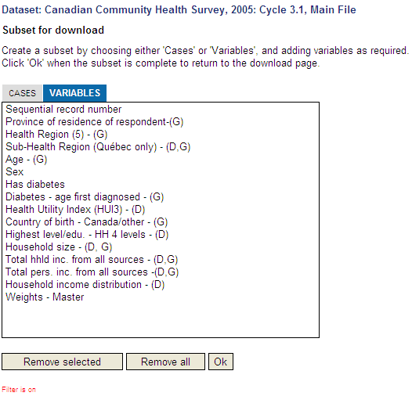
Subset VARIABLES-or cases

- DROP BY THE LIBRARY FOR HELP WITH DATA !

Data librarians are happy to help with…
* Data discovery
* Managing and archiving data
* Accessing data
* Technical questions on data use
* Giving workshops on data and access to data

can’t I get data right away?
YES, Now you can!

“Finding data has never been so easy! ODESI offers great data choices for everybody” -- Susan Mowers, Data Librarian, University of Ottawa

The choice is yours …

* treasure trove of data for delving
* explore data in English and in French
* simple to sophisticated tables to go
* weighted statistics
* pick and choose just the variables you need
* choose your data formats … xls, sav

