- Click on diskette icon to begin downloading

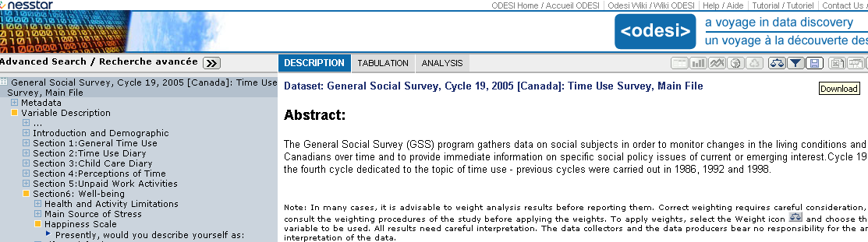

- Click on Subset button
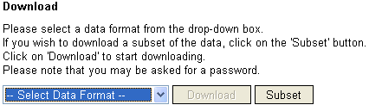
`

- Click on VARIABLES tab

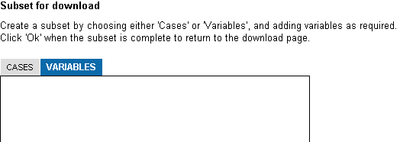

- Click on variable names, one at a time, to download (or click on category names as in example below, Section 6: Well-being), then click on Add to subset.

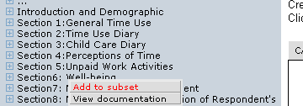

- Ensure you have selected all relevant variables. It is a good idea to review all variables and to include weight variables, demographic and economic variables, and the record identifier in your subset, e.g., Age groups, Sex, Record idenfiication, below.

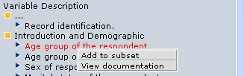
- When you have ensured you have selected all your variables, click Ok

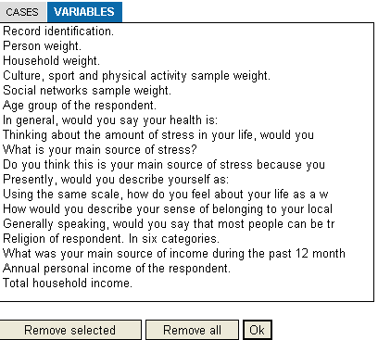

- Select Data Format (e.g., SPSS) then click on Download button

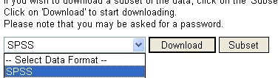

- You may have to click on this link:


- Follow the instructions to save your zipped file, and unzip it once you have saved it

