Search results 2
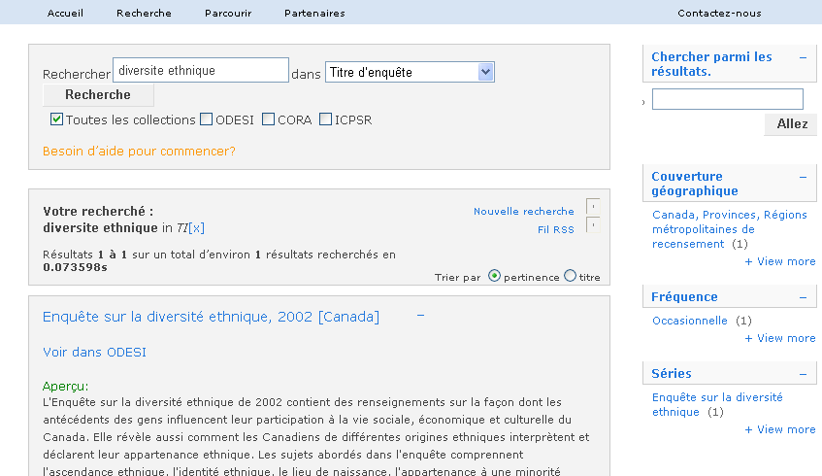
1
2
3

1 Please delete the period at the end– it is confusing with the box below
2 Voir plus
3 dans

