Search details, Data Files tab
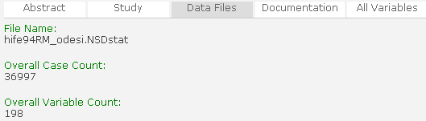
2
3
1
1
2
3

Search details, Documentation tab
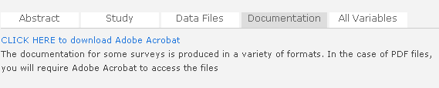
4
4

Search details, All Variables tab
5
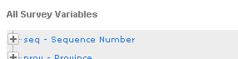

5

