Search details, Study tab
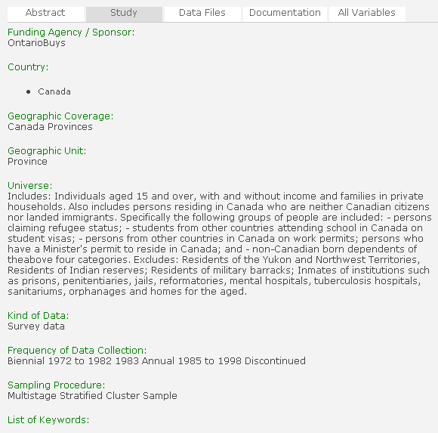
1
2
3
4
5
6
7
8
9

1 | 6
2 | 7
3 | 8
4 | 9
5

