Summary of our “<odesi>” on nutrition and related data

- Go to http://www.odesi.ca  - Select Search tab  √√  Search  - Enter search word(s), click on ODESI (to search DLI holdings), then click on  - Scroll down to 4th hit: Canadian Community Health Survey, 2004: Cycle 2.2, Nutrition General Health Component – scroll to preview Abstract and the categories that follow, e.g, Administration, Alcohol, Chronic conditions, Fruit and vegetable consumption etc.-  - Click on the title: Canadian Community Health Survey, 2004: Cycle 2.2, Nutrition General Health Component and continue to preview by clicking on the tabs | Search
  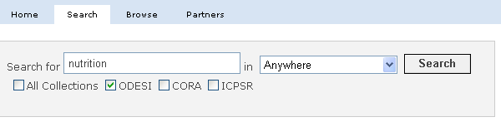
- Click on View in ODESI found just under the title of the survey …    - Explore the data variables prior to downloading your data  +√  - Drill down under Variable Description by clicking on the buttons to the left and variable names  - In addition to Fruit and vegetable consumption, we will drill down under Income (income adequacy) and Chronic conditions (has diabetes) | Explore data
  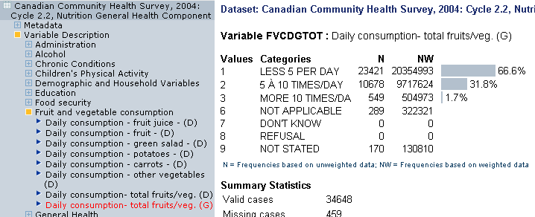

Explore data further using Tabulation Tab  Example 1 Row and Column Percentage  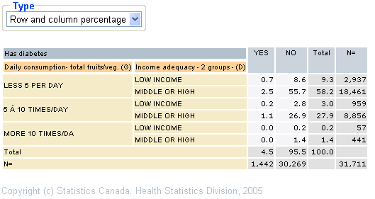  Example 2 Weighted raw numbers  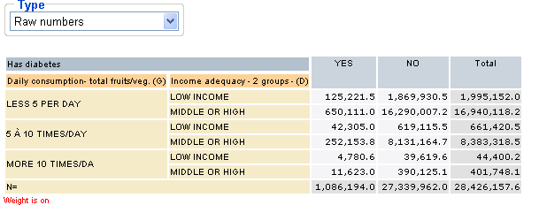 | Tabulate and Weight Data
  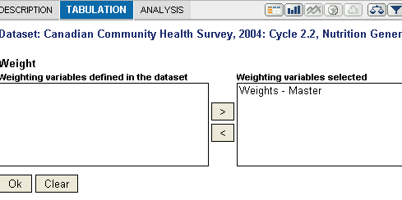
- Click on diskette icon to begin downloading 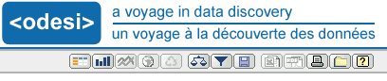  - Select your format and click on Download button  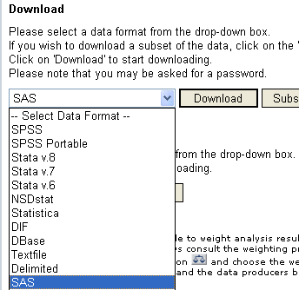  - You may have to click on :    - Follow the instructions to save your zipped file, and unzip it once you have saved it | Download data
- To browse by surveys, go to http://www.odesi.ca again  - Select Browse tab  - Click on the Browse the ODESI Repository by Subject link:  +√  - Using the drill down buttons to the left, drill down through the categories and through the Metadata and Variable descriptions. You will have full access to explore your data, tabulate and download. | Browse
  
  