Summary of our “<odesi>” on happiness and related data

- Go to http://www.odesi.ca  - Select Search tab  √√  - Enter search word(s), click on ODESI (to search DLI holdings), in, select Variable/Category Label, then click on  Search  - Click on date to Sort by date  - Scroll down to 5th hit: General Social Survey, Cycle 19, 2005 [Canada]: Time Use Survey, Main File– scroll to preview Abstract and the categories that follow  6. Click on the title: General Social Survey, Cycle 19, 2005 [Canada]: Time Use Survey, Main File and continue to preview by clicking on the tabs | Search
  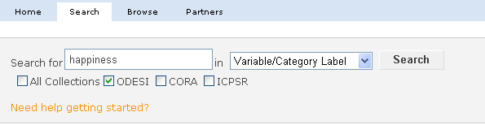
  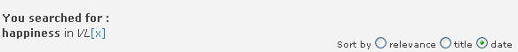
  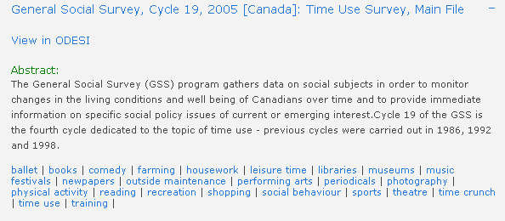
- Click on View in ODESI found just under the title of the survey …  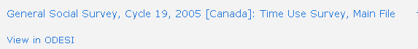  - Explore the data variables prior to downloading your data  +√  - Drill down under Variable Description by clicking on the buttons to the left and variable names  - In addition to Total household income, we will drill down under Section 5: Well-being → Happiness Scale … | Explore data
  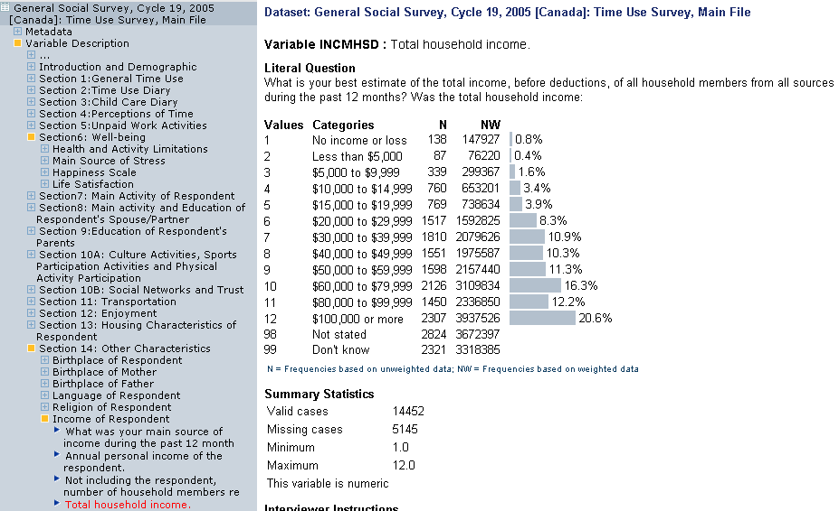

Explore data further using Tabulation Tab  Example 1 Row and Column Percentage  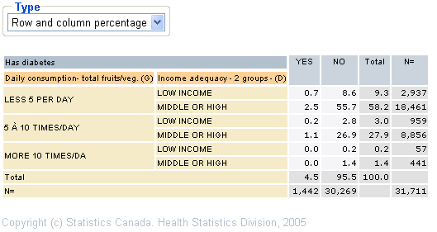  Example 2 Weighted raw numbers  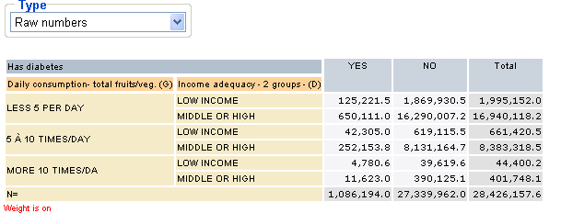 | Tabulate and Weight Data
  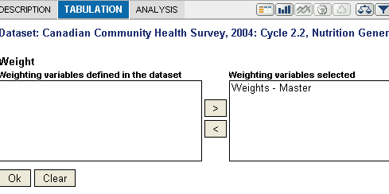
- Click on diskette icon to begin downloading 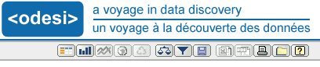  - Select your format and click on Download button  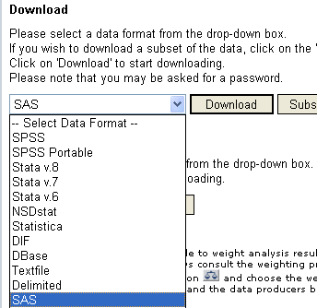  - You may have to click on :    - Follow the instructions to save your zipped file, and unzip it once you have saved it | Download data
- To browse by surveys, go to http://www.odesi.ca again  - Select Browse tab  - Click on the Browse the ODESI Repository by Subject link:  +√  - Using the drill down buttons to the left, drill down through the categories and through the Metadata and Variable descriptions. You will have full access to explore your data, tabulate and download. | Browse
  
  