Publishing to <odesi> Using Nesstar
(using DDI 2.x)

Revised April 20, 2010

Alexandra Cooper, Jeff Moon, Queen’s University
Jane Fry, Carleton University
Amber Leahey, Leanne Hindmarch, Scholars Portal

Table of Contents

1) Introduction 2
2) Obtaining the Dataset 3
3) Preparing the Dataset 4
4) Importing the Dataset into Nesstar Publisher 7
5) Marking Up The Dataset - Creating Metadata From Scratch 8
*TIPS for marking up files 12
6) Marking Up The Dataset - Using Metadata From Other Sources 13
7) Managing Servers 14
8) Publishing in Nesstar 15
9) Templates in Nesstar 16
10) Re-importing the data file into Nesstar 19

Appendix A – Template Guide - Description of the Tags in DDI 2.x ______________________________ 20

Introduction

This guide is focused on marking up and publishing Statistics Canada microdata files for <odesi>. In some cases, marking up other files such as public opinion polls, B2020, or Excel files, will follow the same steps outlined in this guide; however, the data file or tables will come from different sources. In addition, different DDI fields may be used for marking up public opinion polls, B2020, or Excel files. Mark-up students should consult their supervisors for further information when marking up non-Statistics Canada files.

The Best Practices Document (BPD) provides additional information about the creation of metadata in Nesstar for <odesi>. If in doubt, please refer to the BPD for clarification and assistance (http://spotdocs.scholarsportal.info/display/odesi/best+practices+-+english).

Note: This guide assumes that you have SPSS installed on your computer as well as Nesstar Publisher. If you use a statistical package other than SPSS, such as SAS, Stata, or Excel, some of the procedures in Preparing the Dataset (Section 3) may differ. Nesstar Publisher can import data in the following formats:
- DDI Document (*.xml)
- SPSS System (*.sav)
- SPSS Portable (*.por)
- SPSS Syntax (*.sps)
- SAS (*.sp1)
- Stata 7 and Stata 8 (*.dta)
- Statistica (*.sta)
- NSDstat (*.nsf), the old NSDstat format used by NSDstat Pro.
- Obtaining the Dataset

You need to have a microdata file to work with in order to import it into Nesstar Publisher, add metadata, and publish the result to <odesi>’s Nesstar Server (after which the file will appear in <odesi>’s Nesstar Webview at http://odesi.scholarsportal.info). In most cases, this step will be performed by the DLI contact for your institution, since they are the ones with the passwords to access the Statistics Canada files. Mark-up students should consult their supervisors to retrieve the files for them from the appropriate source.

    - Marking up a new file, not currently in <odesi>:
      - Check if Statistics Canada has already marked up the file.
- Statistics Canada Nesstar: http://www62.statcan.ca/webview/
- If needed file is identified, mark-up students ask supervisor to download
- Download the data in SPSS format (.sav)
- Download the documentation in XML format (.xml)
- Unzip both files
- Import the dataset into Nesstar
- Import documentation to the file Documentation → Import from DDI
- Make appropriate updates to the metadata - see Marking up the Dataset – Using Metadata from Other Sources (Section 6)

      - If Statistics Canada has not already marked up the file, download the file from Statistics Canada’s FTP site
- Mark-up students ask supervisor to download
- Data will usually be available in the form of an ASCII text file (.txt or .dat) and a syntax file (.sps).
- Documentation in .xml format will not yet have been created.
- Documentation in the form of a codebook, user guide and/or a questionnaire should be available (.pdf format usually).

    - Correcting a file that is already in <odesi>:
      - If you were the person who originally marked up this file, you will want to work from your saved NSDstat file (produced from going through the process described in this guide when you first marked up the file).
      - If you did not originally mark-up this file, you will need to download the file from <odesi>’s Nesstar (http://odesi.scholarsportal.info).
- Download the data in SPSS format (.sav)
- Download the documentation in XML format (.xml)
- Unzip both files
- Import the dataset into Nesstar
- Import documentation to the file Documentation → Import from DDI
- Make appropriate updates to the metadata – see Marking up the Dataset – Using Metadata from Other Sources (Section 6)

Note: Sometimes, the necessary correction will already have been made by Statistics Canada in the intervening time since the file was first published to <odesi>. You may wish to check if Statistics Canada has already marked up the corrected file. If yes, students should ask their supervisor to download the data and documentation.
- Preparing the Dataset

Before marking up the file (entering the metadata into Nesstar Publisher), always check to ensure that the file is ready for public use. You will need to check for the following:
- there is an id variable;
- all the variable labels are correct and unique (avoid lengthy labels/repeats that read as a literal question);
- all the value labels are correct;
- all the missing values have been declared;
- all the recoded variables are correct; and
- make sure the data are not weighted.

This guide assumes you will perform these checks using SPSS. However, sometimes quick fixes can be made in Nesstar. Generally, you will have either an SPSS system file (.sav format – obtained from <odesi> or Statistics Canada Nesstar), or you will have a combination of an ASCII text file (.txt or .dat) and a syntax file (.sps – obtained from Statistics Canada FTP site). The following will describe how to prepare the dataset in each case.

    - Working with an “.sps” syntax file (creating an SPSS system file .sav)
      - Open the syntax file (.sps file) by double-clicking on it. The .sps file is the program file which converts the raw data file (ASCII text file) to an SPSS system file (.sav) which is then imported into Nesstar.
You will need to modify the SPSS command code to meet local processing needs, as follows:

‘Title’, ‘Set Length’, and ‘File Handle’ commands *Make some changes in this section*
TITLE 'Survey of Labour and Income Dynamics, 2003’. ← title, in single quotes
SUBTITLE ‘Census Family File’.
SET LENGTH=NONE WIDTH=80. ← sets page width
FILE HANDLE INFILE/ NAME='c:\data\HS.txt' /LRECL=841. ← identifies file, gives record length

Give a ‘nickname’ to the raw data file… in this case, we’ll use “INFILE”
… separate subcommands with forward slash
Include the full path where the raw data file is located
… separate subcommands with forward slash
Specify the LRECL (Logical Record Length) for the file
… end with a period
TIP:
All SPSS commands end with a “period”.
All commands start in the first column… subsequent lines in the same command are indented by 1-2 columns.

** “INFILE” – Survey name will be here
** NAME=’…’ (Cut & paste path to working directory/folder: c:\DataCentre…)

‘Data List’ command *Generally don’t change things in this section*
DATA LIST FILE = INFILE/ ← refers to file, identified above in “File Handle” statement
ADMA_RNO 1- 6 ← identifies position of variable “ADMA_RNO” in raw data file
GEOAGPRV 7- 8 ← identifies position of variable “GEOAGPRV” in raw data file
GEOADPMF 9- 13 ← identifies position of variable “GEOADPMF” in raw data file
…. ← more variables would be listed here…
WTSAM 834- 841 (2) ← identifies position of variable “WTSAM” in raw data file
The LRECL (Logical Record Length) can be determined by looking at the last position of the last variable on the raw data file.
The “(2)” indicates that the number being read in should be interpreted as having 2 decimal places.
. ← a period (“.”) signifies the end of this command

‘Variable Labels’ command *This is the section where you will make the most changes*
VARIABLE LABELS
ADMA_RNO 'Sequential record number'
GEOAGPRV 'Province - (G)'
GEOADPMF 'Health Region (5) - (G)'
. ← a period (“.”) signifies the end of this command
Tip: Copy the “Variable Labels” block into a text editor to make the required changes, then copy it back to the SPSS program.
Clean up the variable labels if needed
-check spelling
-spell out words in full (ie cigs = cigarettes)

‘Value Labels’ command *Generally don’t change things in this section*
VALUE LABELS
ADMA_IMP
1 'YES'
2 'NO'
6 'NOT APPLICABLE'
7 'DON''T KNOW'
8 'REFUSAL'
9 'NOT STATED'
/
GEOAGPRV
35 'ONT'
24 'QUE'
/
. ← a period (“.”) signifies the end of this command

‘Missing Values’ command *Make changes in this section when missing values are not declared*
Note: all files in <odesi> should have missing values declared
MISSING VALUES
ADMA_IMP (6 THRU 9)
.

‘Save Outfile’ command
SAVE OUTFILE= 'c:\data\cchs_2000-2001.sav'.
EXECUTE.
Include the full path where the resulting SPSS System file “.sav” is to be saved.
Give the file a meaningful name (survey acronym and year).

      - Once you’ve completed the edits to the syntax file (.sps), you can run the file. SPSS will run the syntax file’s code against the data file referred to.
- Save the file
- From the Menu bar, use the menu command: Run → All to run the code. When it is done, “SPSS processor is ready” will appear at bottom of screen.

      - Check results.
- Check that the SPSS System File (.sav) was saved to the disk location you specified at the bottom of your SPSS program (.sav file will have been added to working directory / folder)
- From within the data editor screen (the one that looks like a spreadsheet), use the menu command: Analyze → Descriptive Statistics → Frequencies
- Choose an appropriate variable (e.g. Province, or some other categorized variable)
- Run the analysis and compare your results (e.g. number of cases) with the number of cases indicated in the “Readme” file or Data Dictionary for the survey
- The .sav file can now be imported into Nesstar Publisher

    - Working with an SPSS system file (.sav) file.
If you are starting directly with a .sav file, you do not need to go through the process that was described in part a) above.
- Open the .sav file in SPSS
- Go through the checklist listed at the beginning of this section.
- Make any needed changes.
- Save the file.
- The .sav file can now be imported into Nesstar Publisher.
- Importing the Dataset into Nesstar Publisher

    - Open Nesstar Publisher

    - Ensure that you’re using an appropriate template (see the Templates in Nesstar (Section 9) for information on how to create Templates if there is not already one for you to use).
      - Click the big blue “T” icon. Template Manager window opens.
      - Highlight the appropriate template → click on Use

    - Import dataset – some files can take a while to import – be patient
      - Click on File → Import Dataset → double click on .sav file
      - Data will be imported and will display in the Variables tab and the Data Entry tab

Note: If you have pre-existing metadata (e.g. you are editing a file that has already been marked up and you have downloaded the documentation in XML format from either Statistics Canada or <odesi>’s Nesstar), see Marking Up the Dataset – Using Metadata From Other Sources (Section 6).
- Marking Up The Dataset - Creating Metadata From Scratch

Below is the list of the tabs for which you will be entering information. Each tab contains a number of fields that must be filled out. See Appendix A for a list of all the fields and the formats for filling the fields for Document Description and Study Description. For more detailed information and examples, please refer to the Best Practices Document
(http://spotdocs.scholarsportal.info/display/odesi/best+practices+-+english).
After entering the metadata, the last two steps in marking up the dataset are saving the .NSDstat file and exporting the .xml file.

Note: If you have existing metadata in XML format, you can import it rather than starting from scratch – in this case, skip to Marking up the Dataset - Using Metadata from Other Sources (Section 6).

    - Document Description
Describes the metadata, that is, the document which you are presently putting together

    - Study Description
Describes the study
NOTE: for Beyond 2020, Excel files, and any other aggregate data only:
- 2.4.1.1 Location of Data Collection - this is the only time this field would be used
- Enter the link to the aggregate data file on the <odesi> ftp server: http://odesi.scholarsportal.info/documentation/{surveyID}/{filename}
  - {surveyID} is the file name of the dataset (minus the file extension)

    - Other Study Materials
Describes other related studies or publications for this data file. To enter a study or publication:
      - Highlight the section the survey is to go under
      - Click ‘+’
      - Enter title of study and any other relevant information

    - File Description
Describes file content and version information for the data
      - File Content
Brief information about what the data covers
      - Data Check
Information on any checks performed on the data
      - Version Statement
        - Version Text
Version number (if there is no version number, insert the date you are working on it)
        - Version Date
Date of revision
        - Version Responsibility
Who is responsible for the revision (eg, Statistics Canada)
        - Version Notes
Reason for revision (eg, errors in processing; re-weighting)
    - Variables
      - Resequence variables
This is very important to do and must be done for each dataset. It adds start and end numbers for each of the variables.
        - Click on Variables → Resequence
      - Declare Weight Variable for entire file
States which variable is the weight variable (repeat for each weight variable). This applies the weight to the entire file; to add weight to individual variables, see (iii) Add weight variable to individual variables below.
        - Choose weight variable (user guide will list weight variable(s))
        - In lower right-hand corner, under Variable Information, check Is Weight Variable (do this for each weight variable)
      - Add weight variable to individual variables
        - Click on Weights tab in the middle of the screen
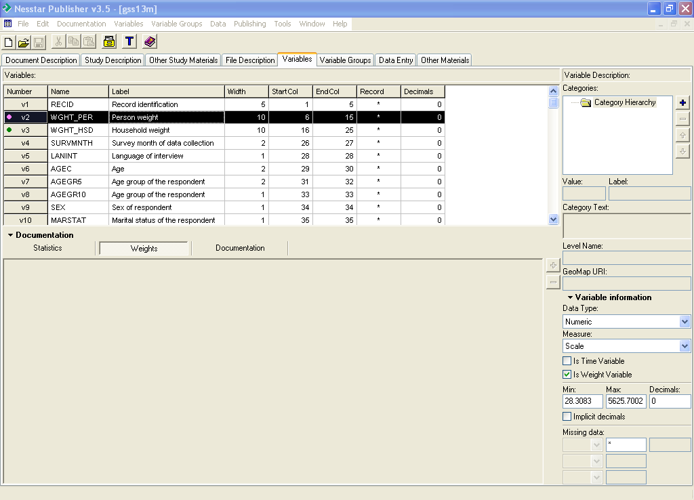

        - Highlight variables that weight is to be added to
        - Click on ‘+’; the Select Variable dialog box opens
        - Choose weight variable and click OK
- if there is more than one weight variable, the proper weight variable must be applied to the appropriate variable. The User Guide will usually have this information.
- if there is more than one weight variable, and each one can be applied to any of the variables (for example, an individual weight, a household weight), then do not do this step.
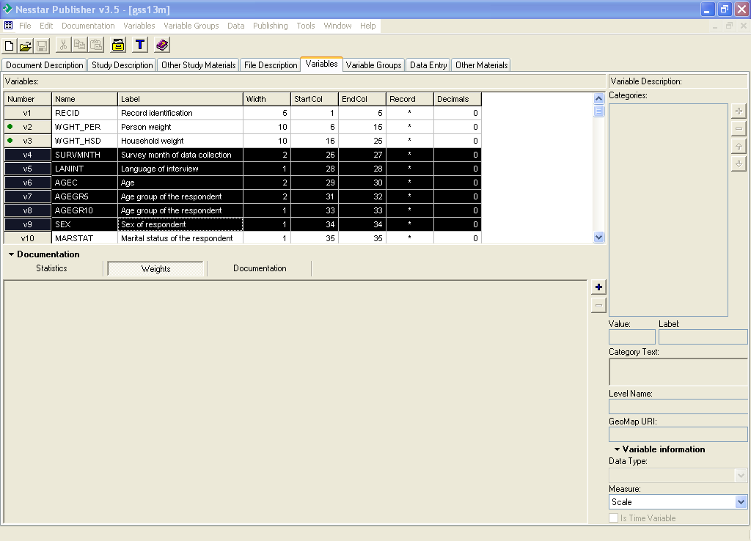

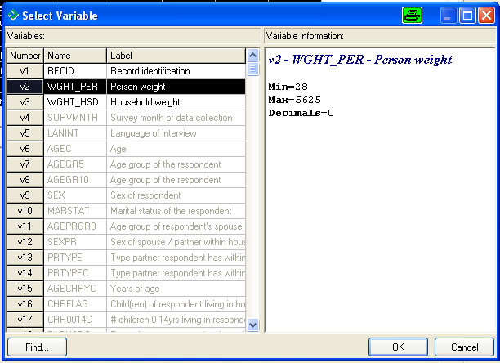

        - Weight variable is now listed under the Weights tab
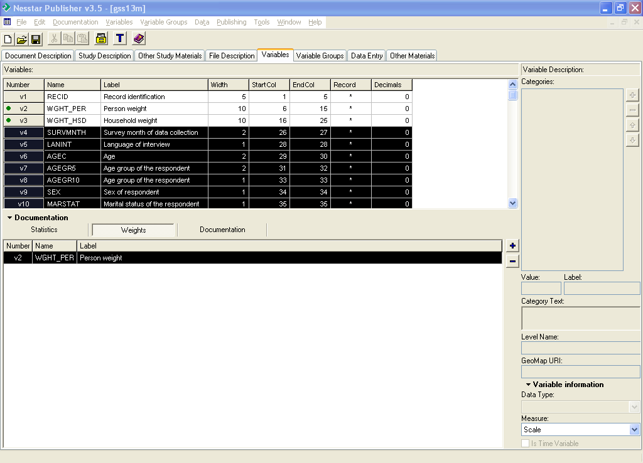

        - Click on Statistics tab, choose variable that weight has been added to.
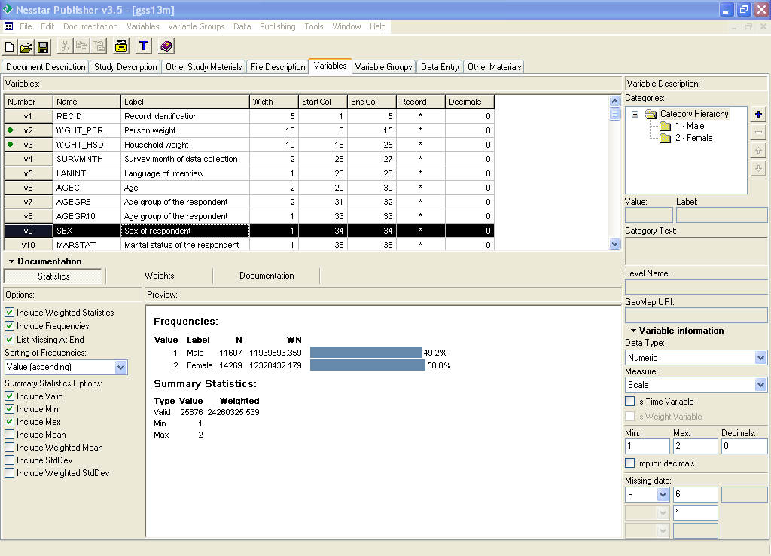
The Preview window will now show the variable with both weight and non-weighted values.

\

      - Check variables (most of this should have been done in SPSS):
        - Variable and value labels correct
        - Missing values declared (if not, dataset will have to be corrected in SPSS and re-imported)
      - Question Text information
        - Go to Documentation tab in the middle of the screen
        - Fill in the Pre-Question Text, Literal Question, Post-Question Text, and Interviewer Instructions, fields. Cut and paste from Questionnaire or User Guide, when possible.
        - Fill in the Universe and Notes fields - this section applies to each individual variable. Cut and paste from codebook or user guide, when possible.

    - Variable Groups
Variable groups cluster variables with similar characteristics. Some basic groups:
Administration – variables that concern the administering of the survey and not the actual respondent or any of their responses, eg. Caseid
Weight – weight variable(s)
Demographics – age, sex, education, etc.
Note: Variables can be in more than one group; i.e. “Languages other than Fr/Eng taught” would be in the Languages Group and the Multiculturalism Group.
      - Create Variable Groups
        - Click on Description tab (right side of screen, under Group Parameters:)
        - On left-hand side, click on Variable Groups, then on ‘+’
        - Type group name in Label: field (right side of screen) and any additional information about the variable group
        - Next variable → click on Variable Groups, then on ‘+’
- if you click on ‘+’ before Variable Groups, you will create a sub-folder of the current group; to remove folder, click on ‘−‘
      - Add Variables to Groups
        - Click on Variables tab (right side of screen, under Group Parameters:)
        - Highlight the Variable Group that you want to add the variables to
        - Click on ‘+’ on far right side of screen
        - Select Variables window opens
        - Choose variables to add, click OK
- a green dot appears beside a variable when it has been added to a group
        - To remove variable from group → highlight variable → click on ‘−‘
        - To move variables up/down → highlight variable → click on ↓ or ↑
        - When done, check the list to make sure all the variables in the dataset have been put in a group. If they are, they will all have a green dot beside them.

    - Data Entry
This section shows the data. Do not change anything here.

    - Other Materials
Provides links to all documentation that accompanies the data file for this study: codebooks; user guides; questionnaires; SPSS and SAS program files; …
      - Click on ‘+’
      - Enter title of study and location on the <odesi> ftp server
- Location of ftp site:
http://odesi.scholarsportal.info/documentation/{surveyID}/{filename}
  - {surveyID} is the file name of the dataset (minus the file extension)

    - Save .NSDstat file
      - File → Save Dataset As…
      - Name file same as .sav and save in appropriate directory → Save

    - Exporting Metadata (.xml file)
Export the file to create the .xml file. Make sure that you have saved the file before exporting the metadata
      - Click on Documentation → Export DDI…
      - Save DDI file as .xml in proper directory
TIPS for marking up files

For Document Description and Study Description the correct title is necessary, including the year and study # (if applicable).
When working on the left-hand side of the page, you can highlight a field to see more detail, which is then shown on the right-hand side of the screen.
When you are filling in the information on the right-hand side and you want to add more entries, click on the ‘+’ sign on the right-hand side. This can be done as often as necessary. It will ensure that the entry is on a different line when it is published. If there is no ‘+’ sign, then it is not possible to add more entries in that particular field.
Likewise, you can click on the ‘–‘ sign to take away an entry you don’t want.
If you want to re-order your entries, put the cursor over the entry you want moved and click once so there is a box around it, and then click on the up or down arrow on the right-hand side.
If there is a Globe icon on the right-hand side, clicking on it will enable you to put in a URI (external link) that is relevant to that particular field.
Correct spelling and grammar are of the utmost importance.
It may seem like you are repeating yourself when you are entering metadata in different sections and that is because you are! Remember that the different fields you are entering information into will appear in different parts of the finished document and must be complete on their own.

Always remember to SAVE the file and export the .xml file regularly!

- Marking Up The Dataset - Using Metadata From Other Sources

As described in Obtaining the Dataset (Section 2), sometimes you are working with a file for which you already have metadata in XML format. For example, you’re correcting a file that was already published in <odesi>, or you’re working on a file that has already been published on the Statistics Canada Nesstar site. In this case, you will import the metadata into Nesstar, edit it as necessary, then save it and export the new .xml file.

    - Import your dataset as described in Importing the Dataset into Nesstar Publisher (Section 4)

    - Import your metadata (.xml file)
      - Documentation → Import from DDI
      - Import Documentation dialog box
        - Uncheck any of the sections you don’t want to import
        - Click OK
        - Find the .xml file
        - Click on Open and the metadata will be added to your file (if a DDI Import Report opens, click on Close)
Note: when importing, the .xml file will override any previous default fields from the template

    - Edit Metadata as described in Marking up the Dataset – Creating Metadata From Scratch (Section 5)
      - Document Description
The following fields must be filled in/changed when editing metadata from another source
- Authoring Entity
The metadata you are creating will be a subsequent version of the metadata you have imported; keep the original author names in the metadata, add your name, and change the production and distribution information
- Version Text
List changes made and name of institution original .xml is from
- Version Responsibility
Name of Institution. Name of Data Centre
- Notes
Indicate what you have edited e.g. “Weighting was added to variables.”, “Variable groups were created”, etc.
- Data of Production
Change to the date you are working on the file
      - Other Materials
- Change filepath for guides
- In most cases it is preferred that documentation be linked to the <odesi> server

    - Save .NSDstat file
      - File → Save Dataset As…
      - Name the file the same as .sav file and then save it in the appropriate directory → Save

    - Exporting Metadata (.xml) - Export the metadata to create the .xml file.
      - File → Save Dataset
      - Click on Documentation → Export DDI
      - Save DDI file as a .xml file in proper directory
      - Click on Close
- Managing Servers

This section shows you how to: add and remove servers; add folders; move folders and files; and delete folders and files.

    - Adding a Nesstar Server
Note: This only has to be done the first time you publish to a particular server
      - Publishing → Add server… dialog box opens
      - Select Server on Internet and enter URL of the server with the port number
      - Enter user-id and password
      - Click OK

    - Removing a Nesstar Server
Note: This only has to be done the first time you publish to a particular server.
      - Publishing → highlight server to be removed → Remove Server

    - Managing Folders on a Nesstar Server
      - Publishing → Server Name → Manage server
      - Add folder
        - Highlight the folder where the new folder is going into
        - Click on ‘+’
        - Type name of new folder and hit Enter
        - Click on folder icon to open Catalog Properties
        - Under Catalog Properties, you can enter information about the folder, if you want to
- Comment: field – this field appears in WebView when you click on the folder
        - Click on Close
      - Delete folder
        - Highlight folder to be deleted
        - Click on ‘–‘
        - Click on Close

    - Managing Files within Folders on a Nesstar Server
note: It moves slowly!
      - Move files between folders
- highlight folder → drag and drop to proper folder
      - Deleting Files
Only delete files within Nesstar Publisher; when a file is published, there are a number of files created but hidden from view. If you don’t delete the file in Nesstar Publisher, the associated files are not deleted.
        - Publishing →Server Name →Manage server
        - Highlight file to be deleted
        - Click on ‘−‘
        - Click on Yes if you want to delete file
        - Click on Close
- Publishing in Nesstar

    - Publish Data and Metadata
      - Open file in Publisher
      - Publishing → highlight server to publish to →Publish data and metadata… → choose server
      - Select catalogs to publish to dialog box → find folder that study belongs in →put checkmark in box beside folder name
        - If a folder does not exist for a file, create a new one using Managing Files within Folders on a Nesstar Server (Managing Servers, Section 7).
        - Check to make sure that no other folder is selected; Publisher will sometimes ‘remember’ previously selected folders
      - Click on Publish
      - Window opens – Working, Please Wait… (some files can take a while to publish)
      - When file is published, Publishing Report will open → click on Close

    - Publish Metadata alone
      - Publishing → highlight server to publish to → Publish metadata only …
      - Select catalogs to publish to dialog box → find folder that study belongs in → put checkmark in box beside folder name
        - If a folder does not exist for a file, create a new one using Managing Files within Folders on a Nesstar Server (Managing Servers, Section 7).
        - check to make sure that no other folder is selected; Publisher will sometimes ‘remember’ previously selected folders
      - Click on Publish
      - Window opens - Working, Please Wait… (some files can take a while to publish)
      - When file is published, Publishing Report will open → click on Close

    - Republish
Only use this for problems that can be fixed in Publisher; if problem is fixed in SPSS, you must re-import the file. See Re-importing the Data File into Nesstar (Section 10)
      - Publishing →highlight server to publish to →Republish
- study will publish to folder(s) originally published to
      - Publishing → Republish on all servers
- this will publish the file to any of the servers it has already been published to
      - Window opens - Working please wait… (some files can take a while to publish)
      - When file is published, Publishing Report will open →click on Close

- Templates in Nesstar

Why use a Template: If you are importing a series of surveys into Nesstar, creating and using a template means that you don’t have to type in the same information again and again and again and again and again. It means that the default fields will already have information in them when you use the correct template for your survey.

    - Creating templates (see Appendix A for a list of the tags)
      - Click on big blue “T”. Template Manager window opens.
      - Click on New on right-hand side
      - Enter information about the template in the Description tag
      - Click on Content tag
      - Left-hand window shows a series of tabs – Document Description, Study Description, File Description, and Variable Description
        - Create groups to organize DDI fields:
          - Highlight one tab (i.e. Document Description) → click on ‘+’
          - Group will be created under Document Description – type name for group (i.e. Title Statement – use something that describes DDI fields in group)
        - Add items to group:
          - Under Available Items: highlight item
          - Click on « (item will be added to template)
        - When you have all the items for Document Description in the template, go to the next tab and repeat steps
        - Groups will hold only a certain number of items; a warning message will appear when a group is full; the good news is that you can have more than one group with the same name
      - Add defaults to items
        - Click on item in left-hand of screen (i.e. 1.1.1.1 Title)
        - Item Description displays information about selected item:
          - Custom Label – DDI field name; can be edited
          - Mandatory – denote if field is mandatory
          - Fixed – users can view but not change field if this box is checked
          - Description – information about DDI field; can be edited; appears in Publisher
          - Defaults – enter default text/values for field
          - Controlled Vocabulary – creates list of terms for a field
- enter text → click on ‘+’ → enter next text
- use arrows to reorganize list
- click on ‘−‘ to remove item from list
      - When you have all the items you need for the template, click on OK, then save template

    - Saving templates
NOTE: In order for the template to be properly saved, you must export it.
      - Click on Export
      - Choose directory to save template in
      - Click on Save *when saving your template, make sure to give it a meaningful name so you will be able to find it again
    - Editing templates
      - Click on big blue “T”. Template Manager window opens.
      - Click on Edit
      - Make changes
      - Click on OK
      - Save template – Export → choose directory → Save
Note: If you don’t do this step, changes will not be saved

    - Importing templates
      - Click on big blue “T”. Template Manager window opens.
      - Click on Import
      - Choose template to import
      - Click on Open
      - Click on Use

    - External Links
External links can be added to some DDI fields to provide links to pages
      - Highlight item on left side of screen
      - Click on Defaults on right side of screen
      - Click on globe beside Default Text: screen
      - Enter URI and Title
      - Click OK
      - External links can also be added in Publisher
highlight item → click on globe on right of screen → enter URI and Title → click OK

    - Using an existing template to create a new template
Before creating the new template, make sure the original template is saved.
As you go through the new template, check all fields and defaults, including external links, since these will all be copied from the original template.
      - Click on the big blue “T”. Template Manager window opens.
      - Highlight the template you want to use from the list of templates.
      - Click on Export ... on the right-hand side.
      - Choose the location you want the template to be saved in.
      - You will be brought back to the Template Manager window. Make sure the template you want to use is highlighted, and then click on Edit ....
      - Template Editor window will open up. Click on the Description tab at the top left.
      - Type in any new information you want saved in the appropriate fields. Click OK on the right-hand side to save it.
      - You will be brought back to the Template Manager. Click on Import.
      - Find the original template you saved a few steps back and click on Open. You will notice that all the templates are now in the list.
      - Highlight the template you want to use and click on Edit....
You will be brought to the Template Editor window. Click on the Content tab on the top left and have fun entering the fields!
Note: When you are going through the new template, check every field as all the defaults that are in the template you copied from, will be in the new template.
    - Adding a default to a template
Why: If you are working on a number of surveys from the same organization, or on a series of surveys, you can add defaults for the tags that are the same across the different surveys. This will save you a great deal of time.
      - Click on the big blue “T”. Template Manager window opens.
      - Highlight the template you want to use from the list of templates
      - Click on Edit in the right-hand box and a Template Editor window comes up. Click on Content tab to get list of entries to be edited
      - Click on the field for which you would like to add the default.
      - Click on the Default button in the right half of the window and add the text you would like to appear.
      - When you are finished, click OK on the right-hand side.
      - Click on Export on the right-hand side to save your changes. If you neglect this step, your changes will NOT be saved.

    - Adding extra lines to a template
      - Click on the big blue “T”. Template Manager window opens.
      - Highlight User Template on the left-hand side and click on Edit on the right-hand side and a template editor comes up.
      - Find the folder you want to add lines to on the left-hand side and click once on it. On the right-hand side you will see the different lines that are available for you to add.
      - Find the line you want to add, double-click on it, and it will be moved over to the left-hand side.

    - Adding a Note Field
This has to be done in the template.
      - Click on the big blue “T”. Template Manager window opens.
      - Highlight the template you are currently using
      - Click on Edit in the right-hand box and a Template Editor window comes up
      - Add the note field to this template
      - Click on OK, Template Editor closes
      - Click on Use, Template Manager closes. Note field will be added to Publisher.

    - Getting rid of an invisible line of writing in a template
This is the line of writing that you can’t see in the template, (eg. the DLI License Link) but when the document is published, the line is there.
      - Click on the big blue “T”. Template Manager window opens.
      - Highlight the template you are currently using
      - Click on Edit in the right-hand box and a Template Editor window comes up
      - Go to the area that you want to change
      - Click on Default on the right-hand side.
      - Delete/change the info in this box. If the box is blank, click on the globe on the right-hand side of the screen and delete/change the URI and any other information that needs to be changed.
      - Click on OK, Template Editor closes
      - Click on Use, Template Manager closes.
- Re-importing the data file into Nesstar

If there is a problem with the data file that cannot be fixed in Publisher, you will have to fix it in SPSS and re-import the datafile. Before you do this, ensure that you have exported the metadata as described above in Marking Up the Dataset – Creating Metadata From Scratch (Section 5). Once you have finished fixing the data file, you must re-import the datafile into Publisher and then also import the metadata as follows.

    - Import dataset – some files can take a while to import – be patient
      - Click on File → Import Dataset → double click on .sav file
      - Data will be imported and will display in the Variables tab and the Data Entry tab

    - Resequence variables
This is very important to do and must be done for each dataset. It adds start and end numbers for each of the variables.
      - Click on Variables → Resequence

    - Declare Weight Variable for entire file
States which variable is the weight variable (repeat for each weight variable). This applies the weight to the entire file; when re-importing into Nesstar, you do not need to add the weight to each individual variable. This information is in the .xml document that will be imported in the next step.
      - Choose weight variable (user guide will list weight variable(s))
      - In lower right-hand corner, under Variable Information, check Is Weight Variable (do this for each weight variable)

    - Import .xml file
      - Documentation → Import from DDI
      - Import Documentation dialog box
        - Uncheck sections you don’t want to import
        - Click OK
      - Find the .xml file → click on Open (metadata is now added to data)
- If a DDI Import Report opens, click on Close

    - Save .NSDstat file
      - File → Save Dataset As…
      - Name file same as .sav and save in appropriate directory → Save

    - Exporting Metadata (.xml file)
Export the file to create the new .xml file. Make sure that you have saved the file before exporting the metadata
      - Click on Documentation → Export DDI…
      - Save DDI file as .xml in proper directory

Appendix A – Template Guide - Description of the Tags in DDI 2.x
Note: This is a list of the possible tags that may be used in your template.

Section 1: Document Description
Citation –Title Statement
      - Title – survey title, year [country, if not in survey title]: subtitle
- same as 2.1.1.1
- General Social Survey, 2005 [Canada]: Cycle 19, Time Use Survey, Main File
- Canadian Tobacco Use Monitoring Survey, 2006: Cycle 1, Household File
      - Subtitle
- same as 2.1.1.2
- include everything after the colon in the title
      - Alternative Title – Acronym Year: Subtitle
- same as 2.1.1.3
- CTUMS 2005: Cycle 1, Household File
- GSS19 2005: Cycle 19, Time Use Survey, Main File
      - Parallel Title (French title)
- same as 2.1.1.4
      - ID Number – acronym_CatalogueNumber_language_year_subset
- same as 2.1.1.5
- ctums_82M0020_E_2004_c1_household-file
Citation – Responsibility Statement
      - Authoring Entity
- name – Last name, First name
- affiliation – Name of Institution. Name of Data Centre
Citation – Production Statement
1.1.3.1 Producer
1.1.3.2 Copyright
1.1.3.3 Production Date
1.1.3.4 Place of Production
- Institution, City, Province, Country
Citation – Production Statement
1.1.3.6 Funding
- used if there is external funding outside of normal operations
Citation – Distribution Statement
1.1.4.1 Distributors
1.1.4.2 Contact Persons
Citation – Series Statement
1.1.5.1 Series Name
1.1.5.2 Series Information
Citation – Version Statement
1.1.6.1 Version Text
- date of version
- most recent version first followed by older versions
1.1.6.1 Version Date
1.1.6.2 Version Responsibility
- Name of Institution. Name of Data Centre
1.1.6.3 Version Notes
- make note of changes made in the document

Bibliographic Citation
1.1.7 Bibliographic Citation
- Name of individual marking up the file. Year. Title of Survey, year. [DDI file format]. Name of Data Centre, Name of Institution, Place. (for full example and guide see the Best Practices Manuel)
Citation - Holdings
1.1.8 Holdings Location
1.1.8 Holdings Call Number
1.1.8 Holdings URI
1.1.8 Holdings Text

Section 2: Study Description
Citation
2.1.1.1 Title – survey title, year [country, if not in survey title]: subtitle
- same as 1.1.1.1
- General Social Survey, 2005 [Canada]: Cycle 19, Time Use Survey, Main File
- Canadian Tobacco Use Monitoring Survey, 2006: Cycle 1, Household File
      - Subtitle
- same as 1.1.1.2
- include everything after the colon in the title
      - Alternative Title – Acronym Year: Subtitle
- same as 1.1.1.3
- CTUMS 2005: Cycle 1, Household File
- GSS19 2005: Cycle 19, Time Use Survey, Main File
      - Parallel Title (French title)
- same as 1.1.1.4
2.1.1.5 ID Number – acronym_CatalogueNumber_language_year_subset
- same as 1.1.1.5
- ctums_82M0020_E_2004_c1_household-file
Citation – Responsibility Statement
2.1.2.1 Authoring Entity
- name of institution as it appears in User Guide, usually on title page
- Statistics Canada. Income Statistics Division
2.1.2.2 Other Identifications
- other divisions mentioned as supporting or contributing to survey
Citation – Production Statement
2.1.3.1 Producer
2.1.3.2 Copyright
- year is release data of the data
2.1.3.3 Date of Production
- release date of the data
- if you are unsure of the date, use one of the following:
    - [1971 or 1972] - one year or the other
    - [1969?] - probable date
    - [between 1906 and 1912] - used only for dates less than 20 years apart
    - [ca. 1960] - approximate date
    - [197-] - decade certain
    - [197-?] - probable decade
    - [18--] - century certain
    - [18--?] - probable century
2.1.3.4 Place of Production
- Institution, City, Province, Country
- Statistics Canada: Ottawa, Ontario, Canada
- Statistics Canada: Ottawa, Ontario, Canada: Special Surveys Division
Citation – Production Statement
2.1.3.6 Funding
- used if there is external funding outside of the normal operating expenses
Distributor Statement
      - Distributors
      - Contact Person
      - Depositor
- the name of the institution (or person) who provided this data collection to the archive storing it
      - Date of Deposit
Distribution Statement
2.1.4.5 Date of Distribution
Series Statement
2.1.5.1 Series Name
2.1.5.2 Series Information
Citation – Version
2.1.6.1 Version
2.1.6.1 Version Date
2.1.6.2 Version Responsibility
2.1.6.3 Version Notes
Bibliographic Citation
2.1.7 Bibliographic Citation
Note: This will be different than the Bibliographic Citation under Document Description
Scope – Subject Information
2.2.1.1 Keywords
- list alphabetical
- capitalize first word
2.2.1.2 Topic Classifications
- subjects
Abstract
2.2.2 Abstract
- take from user guide or Statistics Canada website
Scope – Summary Data Description
2.2.3.1 Time Periods
- time period to which data refers
- year-month-day
2.2.3.2 Dates of Collection
- date when the data was collected
- year-month-day
Scope – Summary Data Description
2.2.3.3 Country
- Canada
2.2.3.4 Geographic Coverage
- each level of geography covered by the data
2.2.3.5 Geographic Unit
- lowest level of geography covered by the data
Scope – Summary Data Description
2.2.3.6 Unit of Analysis
- Individual, Household, Family, Episode
2.2.3.7 Universe
- population covered by file
- Included: all Canadian citizens 15 years of age and older
Excluded: residents of Indian Reserves; and residents of institutions
2.2.3.8 Kind of Data
- census data
- aggregate data
- survey data
Notes – Study Scope
2.2.4 Notes
Methodology – Data Collection
2.3.1.1 Time Method
- cross-sectional
- longitudinal
- time series
2.3.1.2 Data Collectors
- only use if you know specific division
2.3.1.3 Frequency of Data Collection
- Quinquennial – every 5 years
- Biennial – every 2 years
- Annual– every year
- Biannual – twice a year
- Monthly – every month
- Weekly – every week
- Occasional – conducted more than once, but not on a regular basis
- One-time – only conducted once
2.3.1.4 Sampling Procedure
- type of sample and sample design used to select respondents
- Stratified random sample
- Random digit dialing
Methodology – Data Collection
2.3.1.6 Mode of Data Collection
- method used to collect data
- computer assisted, random digit dialing, telephone interview
2.3.1.8 Data Sources
2.3.1.9 Characteristics of the Data Collection Situation
- noteworthy aspects of the data collection; i.e. number of respondents, length of interview
2.3.1.12 Weighting
Notes – Methodology and Processing
2.3.2 Notes
Data Appraisal
2.3.3.1 Response Rate
- percentage of respondents who provided information
2.3.3.2 Estimate of Sampling Error
- measure of how precisely one can estimate a population value from a given value
Data Access – Data Set Availability
2.4.1 Media
2.4.1.1 Location of Data Collection
- this field is used only for Beyond 2020, Excel files, and any other aggregate data
- Enter the link to the aggregate data file on the <odesi> ftp server
(http://odesi.scholarsportal.info/documentation/{surveyID}/{filename})
{surveyID} is the file name of the dataset (minus the file extension)
2.4.1.2 Original Archive where Collection Stored
2.4.1.3 Availability Status
2.4.1.4 Extent of Collection
2.4.1.5 Completeness of Collection Stored
Data Access – Data Set Availability
2.4.1.6 Number of Files
2.4.1.7 Notes
Data Use Statement
2.4.2.3 Restrictions
2.4.2.4 Access Authority (Contact Person)
2.4.2.5 Citation Requirement
2.4.2.7 Access Conditions
2.4.2.8 Disclaimer

Section 3: File Description
File Contents
3.1.2 File Contents
- abstract or description of the data file
Data Check
3.1.8 Extent of Processing Checks
Version Statement
3.1.12.1 Version Text
3.1.12.1 Version Type
3.1.12.1 Version Date
3.1.12.2 Version Responsibility
3.1.12.2 Version Responsibility Affiliation
3.1.12.3 Version Notes
Section 4: Variable Description
Question
4.2.8.1 Pre-Question Text
4.2.8.2 Literal Question
4.2.8.3 Post Question
4.2.8.6 Interviewer Instructions
Universe
4.2.12 Universe
Question
4.2.16 Standard Categories
4.2.16 Standard Categories Date
4.2.19 Coding Instructions
Notes
4.2.24 Notes

