**Tutorial: How to reorganize the variable groups**

Hi everyone!

Sometimes we would like to reorganize the variable~~s~~ group(**s**) of a survey. There ~~is~~ **(are**) two way**(s**) we can do so with the help of the software NesStar Publisher; manually or from importing a NesStar file as a template.

I will use the French version of the ~~Social~~ General (**Socia**l) Survey, (**Cycle 5**), 1990, just because that’s the last one that I have worked on.

1. **Manual method: To set up variable groups from scratch.**

Within NesStar Publisher, we are going to import a study and import the DDI for the ~~SGS~~ (**GSS Cycle 5**) ~~1990~~ and named the file that we are working on to ‘Tutorial_m_esg_1990’ than we click on ‘Variable Groups’. So now we are viewing the variable group of the survey. Our goal is to reorganize these variables into new variables groups.

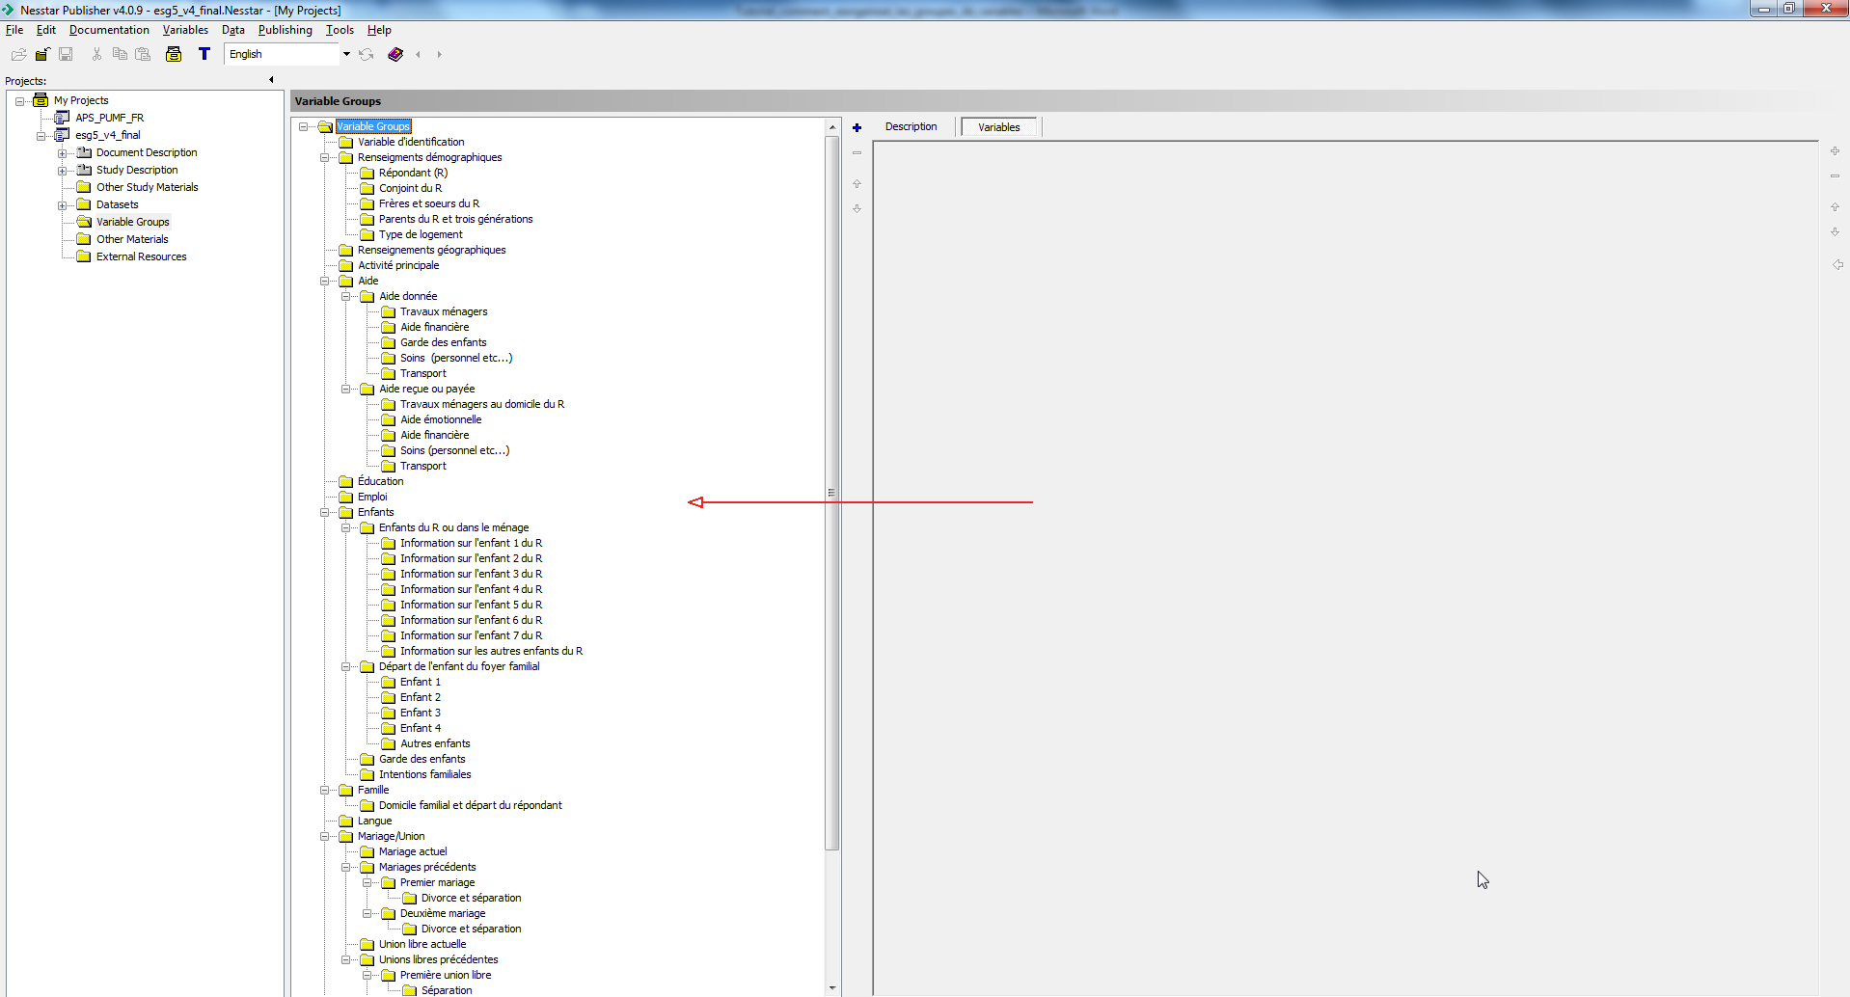

As you can see in the PDF (**display**) on the right (**side of this screen**, **the variable groups will be reorganized** **into a new structure)** ~~this going to be the new Variables group of this survey~~. We are starting with the variables group ‘**Variable d’identification’** (**from top of the new structure**) not ~~as~~ ‘**Activité principale**’ (**from the old structure**).

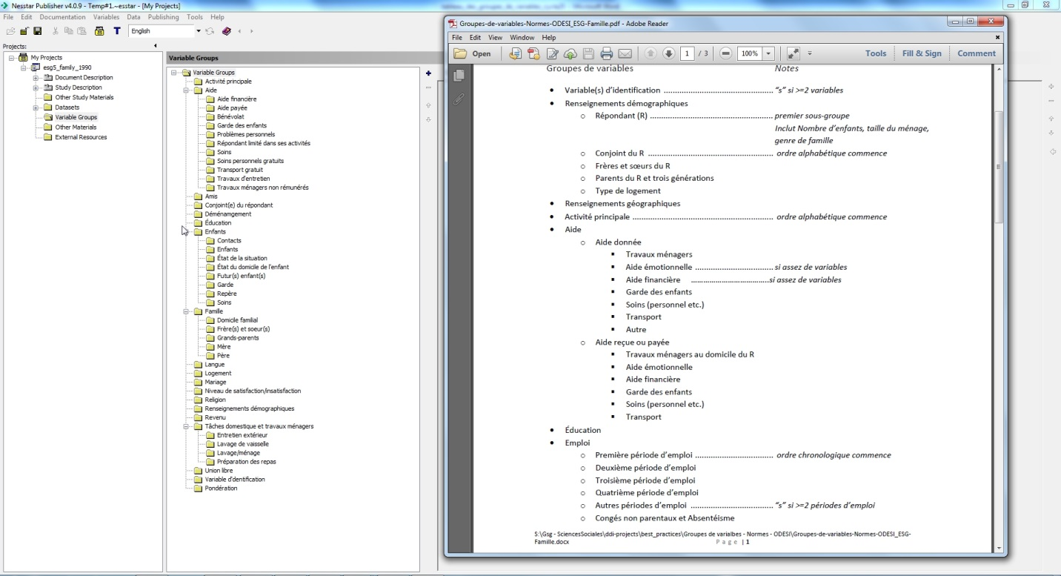

Now that you **have seen what** ~~know how will be~~ the new structure of the variable groups (**which was** **shown to the right**), you must also know where these variables will be placed. I would suggest that you create a MS Word file that will help you visualize where the variables will be. This is an example in MS word of the new distribution with the variable ids.

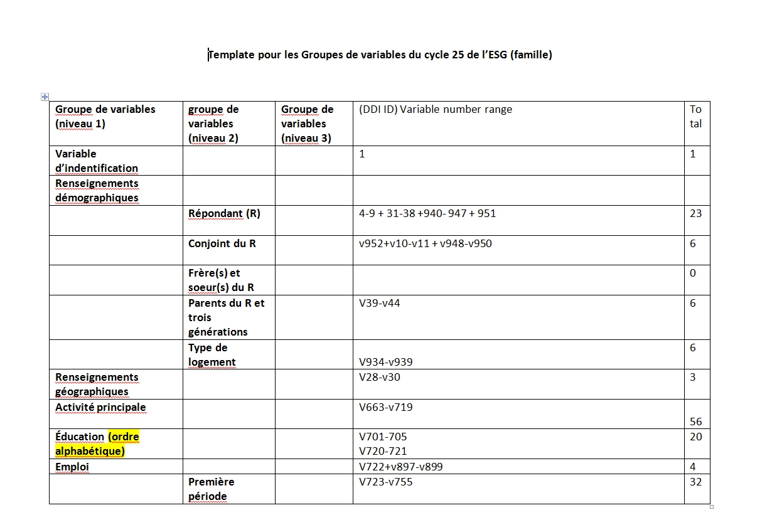

Within the variable group frame we will click on the first variable group and while click-holding the shift key we will click on the last variables group than we will click on the – sign to delete everything. We are going to click the + sign within the variable group frame and create new variables group as shown in the video ‘Mark-up: Creating Variable Groups’. Then we will place some variables within this variable group.

|  |
| --- |
| Is this shown in the video? |

I fast-forward the screencast to let you view the result. This was the manual form to reorganize variables groups.

Now we will do the same by importing a .NesStar file (**using a template, the second method of reorganizing variable groups).**

**2. Importing a file.**

Let’s say that Stat**s**can had republished the ~~same version of~~ **the** ~~SGS~~ (**GSS cycle 5**) with some modification**s** or that you have modified something in the syntax file. For example, I will change a variable label and compile this syntax file so this survey will still have the original variable group because I didn’t work on these files yet.

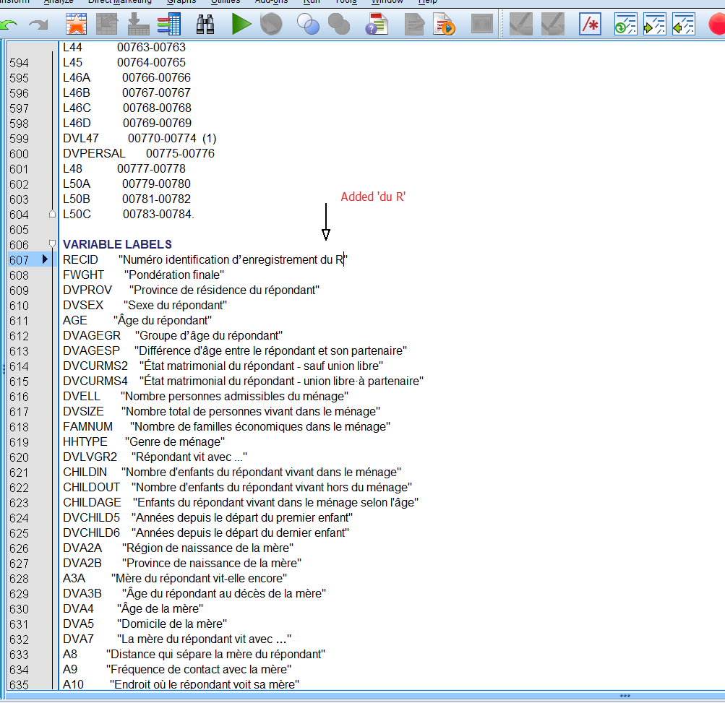

So there is a quicker way to assign new variable group to this survey. But this way assume**s** that we have already done a previous work with that survey like creating the new variable group.

* In NesStar Publisher you are going to import a survey ‘esg5_family_1990_modified’. Then on your browser you can navigate to the Survey page on Odesi, download the documentation in xml and unzip it.

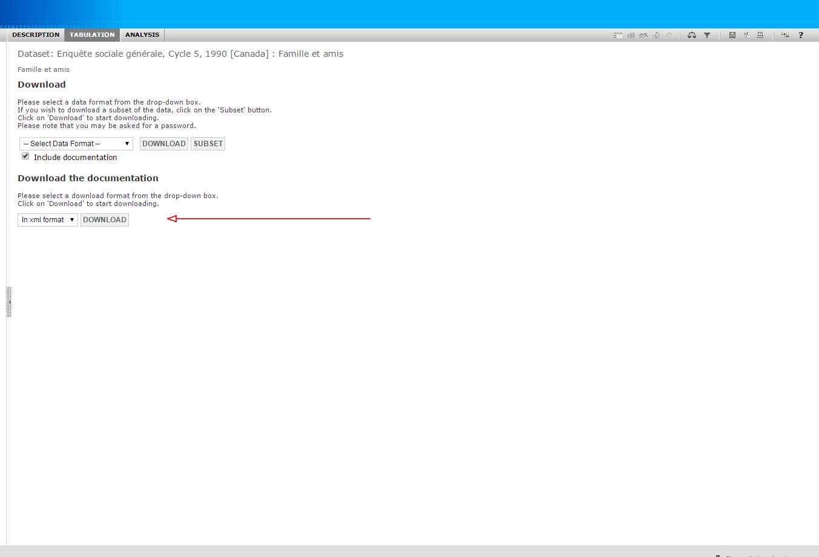

In Nesstar, you will then need to import this unzip file as a template. **Documentation > Import > Import from DDI**. There will be another window that will pop up you are going to select everything except ‘Variables Information’ because we don’t want to import the variable label and then click on OK. Than another window again will pop up, now you will select the .nesStar file that we worked on previously ‘Tutorial_m_esg_1990’

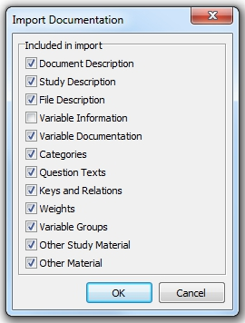

Extra

If you everything is ok than you can upload the files to the servers. By clicking on **Publishing > The Odesi Staging Server > Study > Republish** or **Publish metadata** **only**.

Extra….

If you have a warning telling you that ‘all variables have to be placed in groups before you are able to publish’ than you can click on the + sign on the right side of the variables group frame to view all the variables and anyone of theses that doesn’t have a circle by the variable id means that this variables had not been assigned to a variable group.

