<odesi> Survey Example – Canadian Community Health Survey (CCHS)

Your mission: To find, subset and download data from the Canadian Community Health Survey 2010 (CCHS)
Part 1: Find your survey
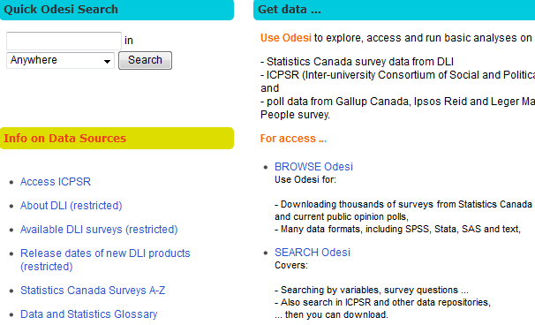
Step 1. Open a Mozilla Firefox session.
Step 2. Click on SEARCH Odesi on the Data and Statistics page at:
http://uottawa.ca.libguides.com/content.php?pid=14807&sid=99466.

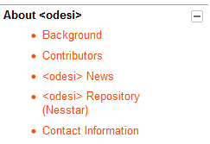
Step 3. Click on <odesi> Repository (Nesstar) on the left hand side. | 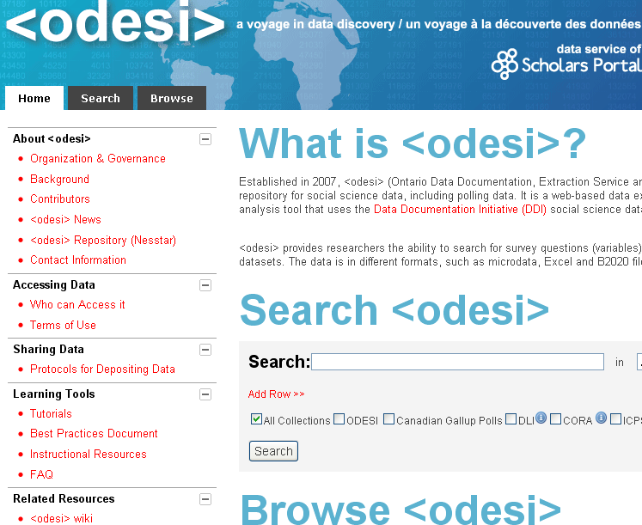

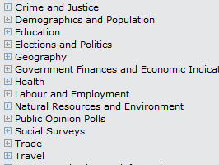
Step 4. Click on the on the left of Health. | 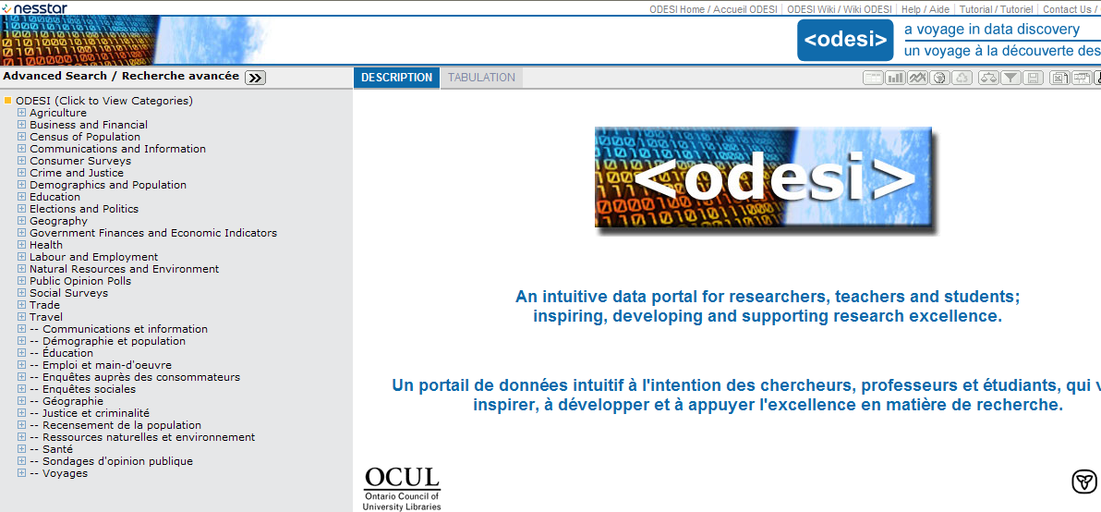

Step 5. Click on the on the left of CANADA.

Step 6. Click on the on the left of Canadian Community Health Survey (CCHS). | 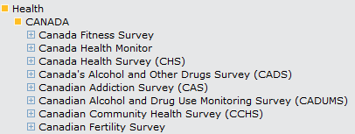

Step 7. Click on the on the left of your selected cycle (year(s)) of the Canadian Community Health Survey, e.g., 2010. | 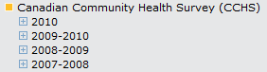

Step 8. Click on the on the left of Canadian Community Health Survey, 2010: Annual component. | 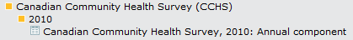

Step 9. You now have full access to the features for your survey, such as Metadata (documentation), the data: Variable Description, Tabulation, Weighting and Downloading.
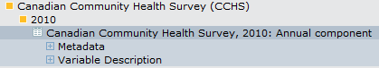
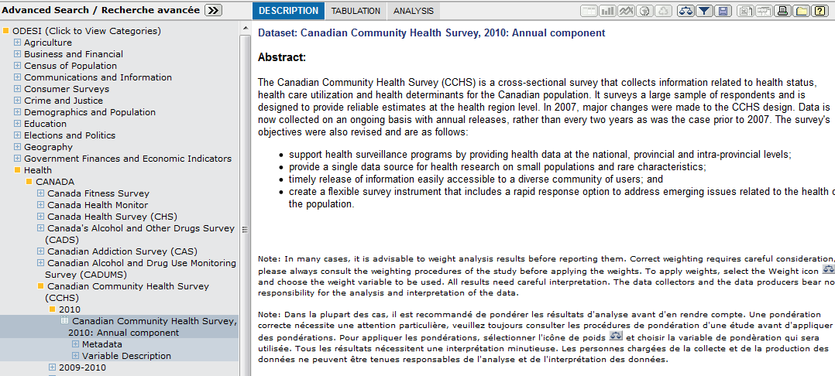
Variable Description
Metadata

Step 10. View your survey documentation. Click on the on the left of Metadata, and note: Study Description, Data Files Description and Other Documentation.  Remember to save all the survey documents you may need for future reference to your computer or memory stick. | 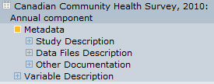

Step 11. For citation information, click on the on the left of Study description, then click on the on the left of Bibliographic Citation.  The Bibliographic Citation elements found in the DESCRIPTION area to the right need to be put into the appropriate style. For example, the APA 6th edition citation for this survey would be:  Statistics Canada. (2011). Canadian Community Health Survey, 2010: Annual component [Data file and code book]. Retrieved from https://login.proxy.bib.uottawa.ca/login?url=http://www.odesi.ca/ | 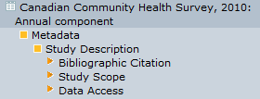

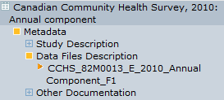
Step 12. For information about the size of the data files, click on the on the left of Data Files Description, then click on the on the left of CCHS_82M0013_E_2010_Annual Component_F1.
For example, this survey has 62 909 cases and 1 325 variables.

Step 13.  - View your survey documentation!! Click on the on the left of Other Documentation, then click on the on the left of the desired documentation, e.g., Codebook.  - Note all the documentation available and be sure to check the Alphabetic Index - PUMF, Derived Variable (DV) Specifications and the Questionnaire. | 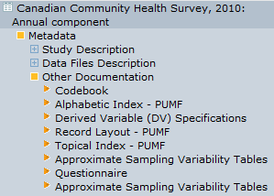

Step 14. View your document(s).
Click on the title of the desired document, e.g., Codebook in the DESCRIPTION window to the right.
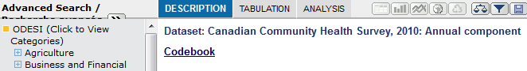

Step 15. Download all relevant document(s).
Right click on your document and Save it to your USB key or a folder on your computer.

Part 2: SUBSET by VARIABLES & CASES and DOWNLOAD
Step 16. We will continue from the previous step.
Step 17. To begin the subsetting process, click on the download icon on the top right.

Step 18. Click on the to select your Data Format. |  | 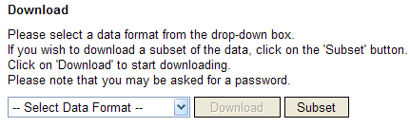
Step 19. Scroll down the list and click on your data format of choice.  Hint: For this example, we will choose SPSS. You may wish to choose another data format. |  | 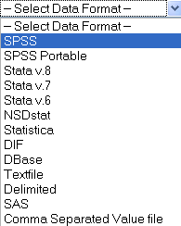
Step 20. Click on the Subset button.
Step 21. Click on the Variables tab. |  | 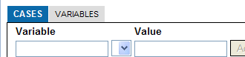
Step 22. The Variables window appears. |  | 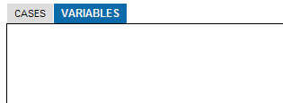
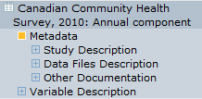
Step 23. Click on the on the left of Variable Description to start the selection of variables.

Step 24. Click on the to the left of a category of interest, e.g., Eye examinations (EYX). |  | 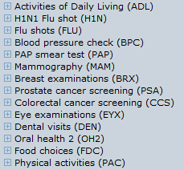
Step 25. Odesi will give you the list of variables under the category, Eye examinations (EYX). |  | 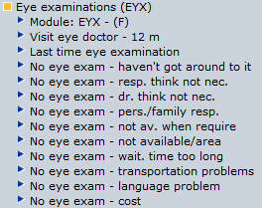
Step 26. You may select variables one at a time. To do this, click on the variable name No eye exam – haven’t got around to it.

Step 27. Click on View documentation if you want to see the frequency for this particular variable or the original literal question before selecting it for subsetting. |  | 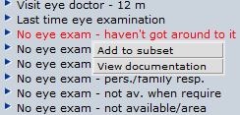
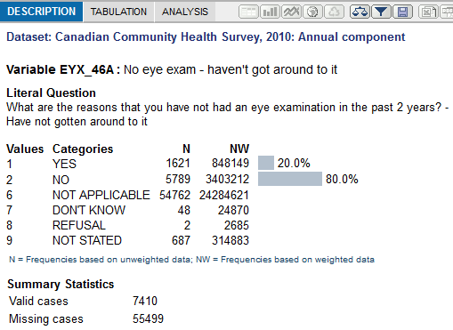
Step 28. Note the description displays frequencies of the age group values (N=Not weighted, NW=Weighted).

Step 29. Click on the back arrow of your browser to go back to subset this variable. |  | 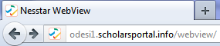
Step 30. Click on the variable name No eye exam – haven’t got around to it. Then click on Add to subset.

Step 31. Your variable(s) will now appear in the Variables box. |  | 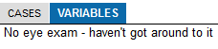
Step 32. Click on the wording, Eye examinations (EYX). We can quickly add all variables to our subset.
Hint: Many times it is advisable to select an entire category of variables such as Eye examinations (EYX) to a subset.
Step 33. Click on Add to subset and note all Eye examinations (EYX) variables are selected in the Variables box to the right. If you are not given this option, check the right-hand window and make sure that Variables is highlighted. |  | 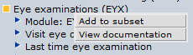
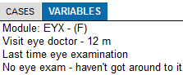
Step 34. Repeat steps 26 to 33 until you have selected all your variables. Ensure you have selected all weight variables and the Sequential record number before going on to step 35 (subsetting specific cases).
Step 35. Click on the Cases tab.

Step 36. The Cases window appears.

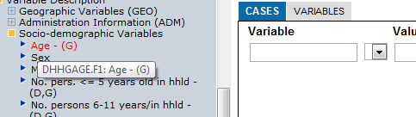
Step 37. Click on a variable for which you would
like certain cases only, e.g., Teenagers.

The variable is Age – (G), under Socio-demographic
Variables.

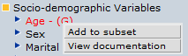
Step 38. Click on Add to subset.

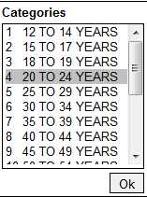
Step 39. Here you only want the answers to the respondents under the age of 20. Click on 4 20 TO 24 YEARS under Categories to select the value.

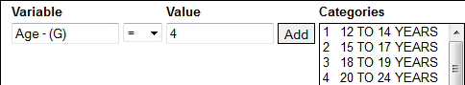
Step 40. Click on the Add button.

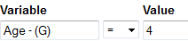
Step 41. Click on the button.

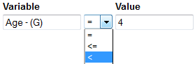Step 42. Scroll down the list and click on .
In this specific case, we have filtered the answers from every respondent under the value 4 (under the age of 20-24).

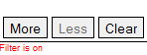
Step 43. If you have more cases to add, click More and continue.
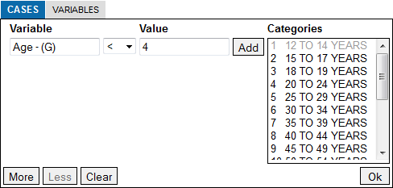
Step 44. When you are finished choosing all the variables and cases, click on the Ok button to start the downloading process.

Step 45. Click on the Download box and wait until the following line below (step 46) appears on your screen...
Step 46. Click on the line If the download does not start automatically, press this link.  Note: You may not get this prompt.  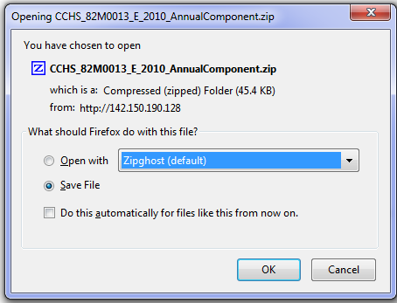 |  | 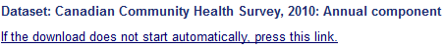
Step 47. Click on the Ok button to save the file.

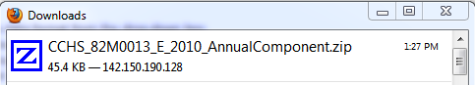
Step 48. Double click on CCHS_82M0013_E_2010_AnnualComponent.zip in the Downloads window.
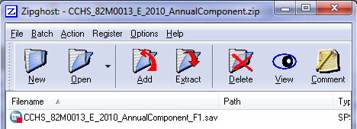
Step 49. Double click on CCHS_82M0013_E_2010_AnnualComponent_F1.sav to open the file in SPSS.

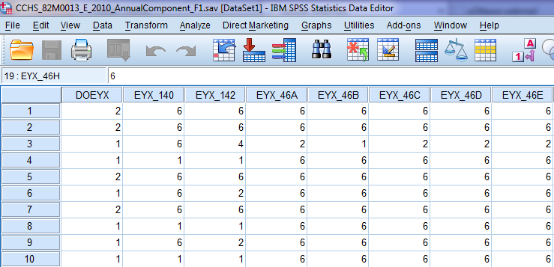
Step 50. The file containing the chosen variables from the previous steps will open into SPSS.

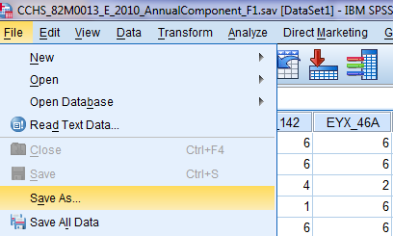
Step 51. Click on the Save as… button in the File tab in the top left corner.

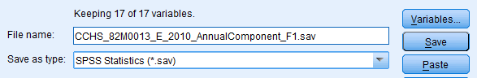  Step 52. Navigate in your Look in: window to save the data to a known directory, e.g., c:\data\.  Hint: You may want to create a new data directory for this purpose. |  | 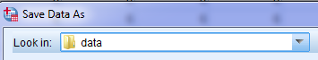
Step 53. Click on the Save button.
Step 54. You are now done saving the file and can open it into SPSS.

Thank you to Carleton University Library Data Centre
for collaborating on this guide.

